**Problem Statement 1**- Develop an Android Application to display some text on the screen

**Objective-** To print some Text on the screen.

# Activity_main.xml file

<?xml version="1.0" encoding="utf-8"?>

<LinearLayoutxmlns:android="[http://schemas.android.com/apk/res/android"](http://schemas.android.com/apk/res/android) xmlns:app="<http://schemas.android.com/apk/res-auto>" xmlns:tools="<http://schemas.android.com/tools>" android:layout_width="match_parent" android:layout_height="match_parent"

tools:context=".MainActivity" android:gravity="center">

<TextView android:layout_height="wrap_content" android:layout_width="wrap_content" android:text="Hi! How are you?"/>

</LinearLayout>

package com.example.my_textapplication;

# MainActivity.java file

import androidx.appcompat.app.AppCompatActivity; import android.os.Bundle;

public class MainActivity extends AppCompatActivity { @Override

protected void onCreate(Bundle savedInstanceState) { super.onCreate(savedInstanceState); setContentView(R.layout.activity_main);

}

}

# AndroidManifest.xml file

<?xml version="1.0" encoding="utf-8"?>

<manifest xmlns:android="[http://schemas.android.com/apk/res/android"](http://schemas.android.com/apk/res/android) xmlns:tools="<http://schemas.android.com/tools>">

<application android:allowBackup="true"

android:dataExtractionRules="@xml/data_extraction_rules" android:fullBackupContent="@xml/backup_rules" android:icon="@mipmap/ic_launcher"

android:label="@string/app_name" android:roundIcon="@mipmap/ic_launcher_round" android:supportsRtl="true" android:theme="@style/Theme.My_textApplication" tools:targetApi="31">

<activity android:name=".MainActivity" android:exported="true">

<intent-filter>

<action android:name="android.intent.action.MAIN" />

<category android:name="android.intent.category.LAUNCHER" />

</intent-filter>

<meta-data android:name="android.app.lib_name" android:value="" />

</activity>

</application>

</manifest>

**OUTPUT**

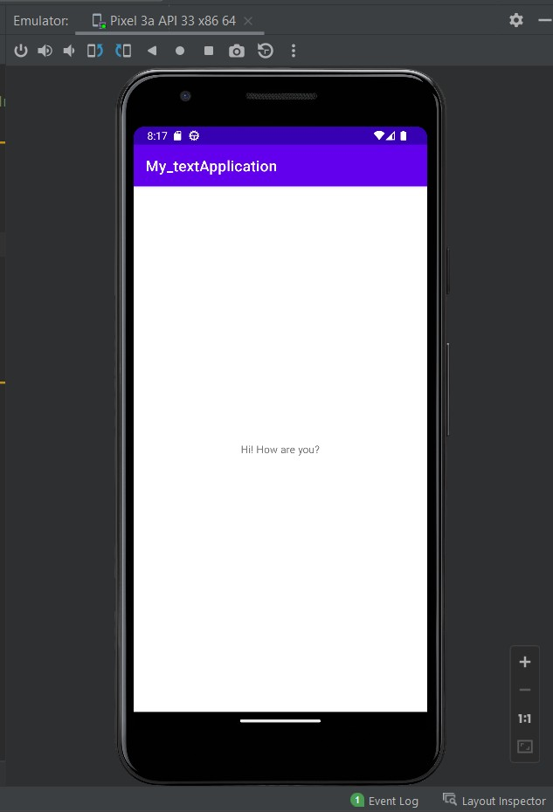

**Problem Statement 2**- Develop an Android Application to change the Background Color on button click

**Objective-** To change the Button color.

# Activity_main.xml file

<?xml version="1.0" encoding="utf-8"?>

<LinearLayoutxmlns:android="[http://schemas.android.com/apk/res/android"](http://schemas.android.com/apk/res/android) xmlns:app="<http://schemas.android.com/apk/res-auto>" xmlns:tools="<http://schemas.android.com/tools>" android:layout_width="match_parent" android:layout_height="match_parent"

tools:context=".MainActivity" android:gravity="center">

<TextView android:layout_width="wrap_content" android:layout_height="wrap_content" android:text="Hello!!!!" android:textSize="50dp" />

<Button android:id="@+id/b1" android:layout_width="200dp" android:layout_height="60dp" android:text="Button1" />

</LinearLayout>

# MainActivity.java file

package com.example.my_colorapplication1;

import androidx.appcompat.app.AppCompatActivity; import android.graphics.Color;

import android.os.Bundle; import android.view.View; import android.widget.Button;

public class MainActivity extends AppCompatActivity{ @Override

protected void onCreate(Bundle savedInstanceState){ super.onCreate(savedInstanceState); setContentView(R.layout.activity_main);

Button btn;

btn = findViewById(R.id.b1); btn.setOnClickListener(new View.OnClickListener() {

@Override

public void onClick(View v){

btn.setBackgroundColor(Color.CYAN);

}

});

}

}

# AndroidManifest.xml file

<?xml version="1.0" encoding="utf-8"?>

<manifest xmlns:android="[http://schemas.android.com/apk/res/android"](http://schemas.android.com/apk/res/android) xmlns:tools="<http://schemas.android.com/tools>">

<application android:allowBackup="true"

android:dataExtractionRules="@xml/data_extraction_rules" android:fullBackupContent="@xml/backup_rules" android:icon="@mipmap/ic_launcher" android:label="@string/app_name" android:roundIcon="@mipmap/ic_launcher_round" android:supportsRtl="true" android:theme="@style/Theme.My_colorApplication1" tools:targetApi="31">

<activity android:name=".MainActivity" android:exported="true">

<intent-filter>

<action android:name="android.intent.action.MAIN" />

<category android:name="android.intent.category.LAUNCHER" />

</intent-filter>

<meta-data android:name="android.app.lib_name" android:value="" />

</activity>

</application>

</manifest>

**OUTPUT**

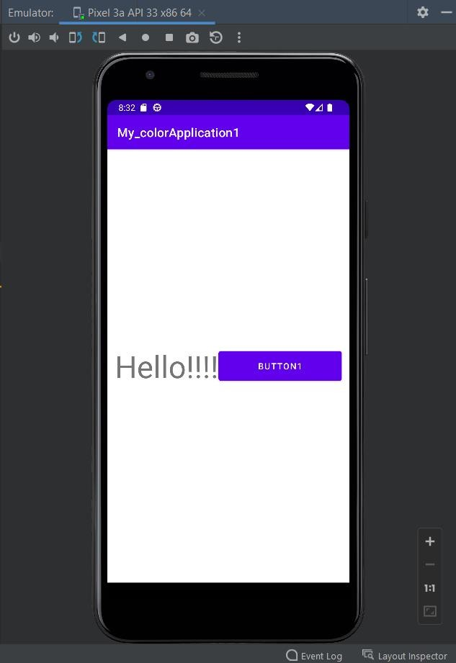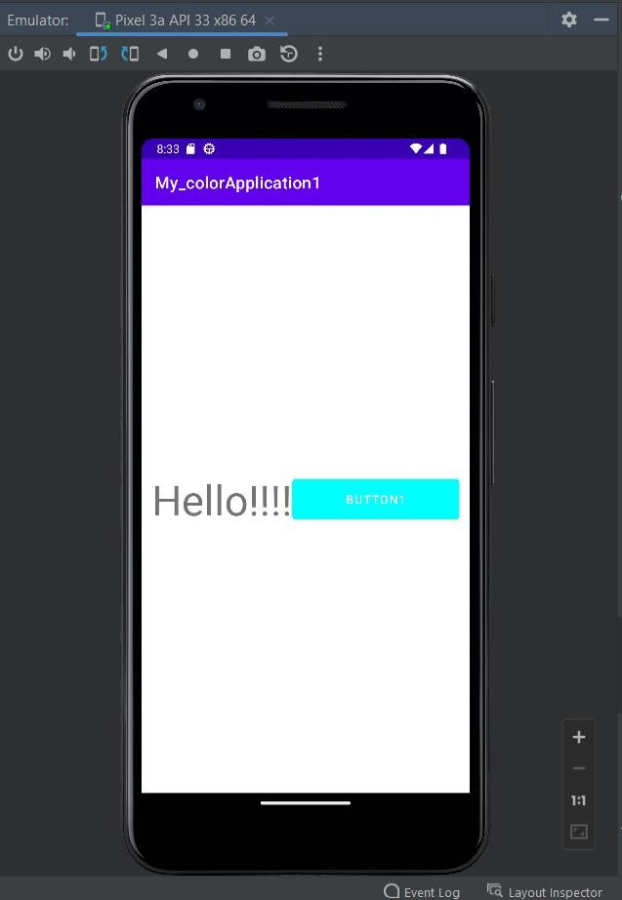

**Problem Statement 3-**Develop an Android Application to change the color of written text on button click

**Objective-** To change background color of a text box on button click

# Activity_main.xml file

<?xml version="1.0" encoding="utf-8"?>

<LinearLayoutxmlns:android="[http://schemas.android.com/apk/res/android"](http://schemas.android.com/apk/res/android) xmlns:app="<http://schemas.android.com/apk/res-auto>" xmlns:tools="<http://schemas.android.com/tools>" android:layout_width="match_parent" android:layout_height="match_parent"

tools:context=".MainActivity" android:id="@+id/L1" android:gravity="center">

<TextView android:layout_width="wrap_content" android:layout_height="wrap_content" android:text="Hello World!" />

<Button android:text="Button1" android:id="@+id/b1" android:layout_height="60dp"

android:layout_width="200dp" />

</LinearLayout>

# MainActivity.java

package com.example.my_colorapplication2;

import androidx.appcompat.app.AppCompatActivity; import android.graphics.Color;

import android.os.Bundle; import android.view.View; import android.widget.Button;

import android.widget.LinearLayout;

public class MainActivity extends AppCompatActivity { @Override

protected void onCreate(Bundle savedInstanceState) { super.onCreate(savedInstanceState); setContentView(R.layout.activity_main); setContentView(R.layout.activity_main);

Button btn; LinearLayout l;

btn = findViewById(R.id.b1); l=findViewById(R.id.L1);

btn.setOnClickListener(new View.OnClickListener() { @Override

public void onClick(View v){ l.setBackgroundColor(Color.CYAN);

}

});

}

}

# AndroidManifest.xml file

<?xml version="1.0" encoding="utf-8"?>

<manifest xmlns:android="[http://schemas.android.com/apk/res/android"](http://schemas.android.com/apk/res/android) xmlns:tools="<http://schemas.android.com/tools>">

<application android:allowBackup="true"

android:dataExtractionRules="@xml/data_extraction_rules" android:fullBackupContent="@xml/backup_rules" android:icon="@mipmap/ic_launcher" android:label="@string/app_name" android:roundIcon="@mipmap/ic_launcher_round" android:supportsRtl="true" android:theme="@style/Theme.My_colorApplication2" tools:targetApi="31">

<activity android:name=".MainActivity" android:exported="true">

<intent-filter>

<action android:name="android.intent.action.MAIN" />

<category android:name="android.intent.category.LAUNCHER" />

</intent-filter>

<meta-data android:name="android.app.lib_name" android:value="" />

</activity>

</application>

</manifest>

**OUTPUT**

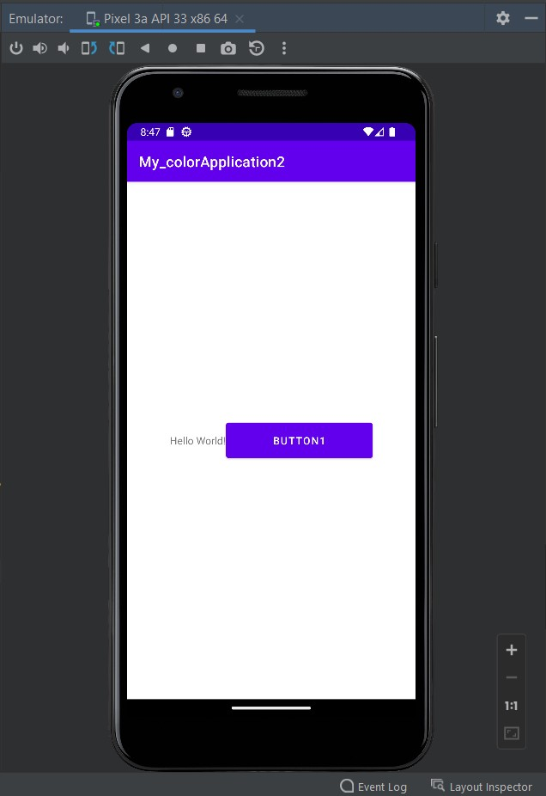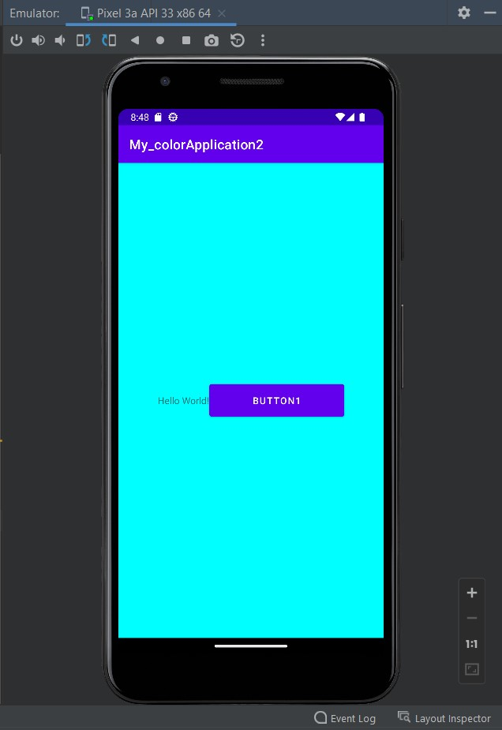

**Problem Statement 4-**Develop an Android Application to change the color of another button on button click

**Objective-** To change background color of another button on button click.

# Activity_main.xml file

<?xml version="1.0" encoding="utf-8"?>

<LinearLayoutxmlns:android="[http://schemas.android.com/apk/res/android"](http://schemas.android.com/apk/res/android) xmlns:app="<http://schemas.android.com/apk/res-auto>" xmlns:tools="<http://schemas.android.com/tools>" android:layout_width="match_parent" android:layout_height="match_parent"

tools:context=".MainActivity" android:gravity="center">

<Button android:text="Button1" android:id="@+id/b1" android:layout_height="60dp"

android:layout_width="200dp" />

<Button android:text="Button2" android:id="@+id/b2" android:layout_height="60dp"

android:layout_width="200dp" />

</LinearLayout>

# MainActivity.java

package com.example.my_colorapplication3;

import androidx.appcompat.app.AppCompatActivity; import android.graphics.Color;

import android.os.Bundle; import android.view.View; import android.widget.Button;

public class MainActivity extends AppCompatActivity { @Override

protected void onCreate(Bundle savedInstanceState) { super.onCreate(savedInstanceState); setContentView(R.layout.activity_main);

Button btn1,btn2;

btn1 = findViewById(R.id.b1);

btn2=findViewById(R.id.b2); btn1.setOnClickListener(new View.OnClickListener() {

@Override

public void onClick(View v){ btn2.setBackgroundColor(Color.CYAN);

}

});

}

}

# AndroidManifest.xml file

<?xml version="1.0" encoding="utf-8"?>

<manifest xmlns:android="[http://schemas.android.com/apk/res/android"](http://schemas.android.com/apk/res/android) xmlns:tools="<http://schemas.android.com/tools>">

<application android:allowBackup="true"

android:dataExtractionRules="@xml/data_extraction_rules" android:fullBackupContent="@xml/backup_rules" android:icon="@mipmap/ic_launcher" android:label="@string/app_name" android:roundIcon="@mipmap/ic_launcher_round" android:supportsRtl="true" android:theme="@style/Theme.My_colorApplication3" tools:targetApi="31">

<activity android:name=".MainActivity" android:exported="true">

<intent-filter>

<action android:name="android.intent.action.MAIN" />

<category android:name="android.intent.category.LAUNCHER" />

</intent-filter>

<meta-data android:name="android.app.lib_name" android:value="" />

</activity>

</application>

</manifest>

**OUTPUT**

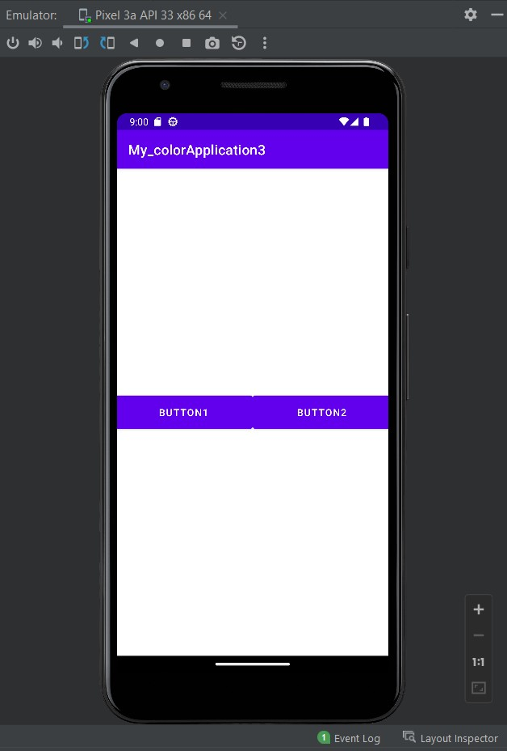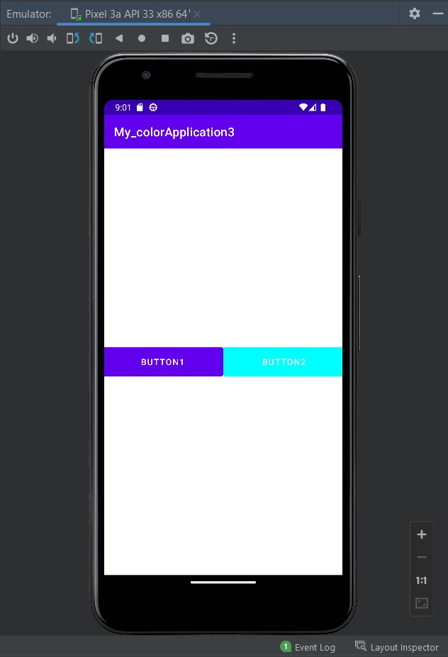

**Problem Statement 5-**Develop an Android Application to depict the Activity Life Cycle

**Objective-** To Learn about Activity Life Cycle.

# Activity_main.xml file

<?xml version="1.0" encoding="utf-8"?>

<LinearLayoutxmlns:android="[http://schemas.android.com/apk/res/android"](http://schemas.android.com/apk/res/android) xmlns:app="<http://schemas.android.com/apk/res-auto>" xmlns:tools="<http://schemas.android.com/tools>" android:layout_width="match_parent" android:layout_height="match_parent"

tools:context=".MainActivity" Android:gravity=”center”>

<TextView android:layout_width="wrap_content" android:layout_height="wrap_content" android:text="Hello World!"

/>

</LinearLayout>

# MainActivity.java

package com.example.myactivitylifecycle;

import androidx.appcompat.app.AppCompatActivity; import android.os.Bundle;

import android.util.Log;

public class MainActivity extends AppCompatActivity {

public static final String status=MainActivity.class.getSimpleName(); @Override

protected void onCreate(Bundle savedInstanceState) { super.onCreate(savedInstanceState); setContentView(R.layout.activity_main); Log.i(status,"in method on create");

}

@Override

protected void onStart() { super.onStart();

Log.i(status,"in method on start");

}

@Override

protected void onRestart() {

super.onRestart();

Log.i(status,"in method on Restart");

}

@Override

protected void onResume() { super.onResume();

Log.i(status,"in method on Resume");

}

@Override

protected void onStop() { super.onStop();

Log.i(status,"in method on Stop");

}

@Override

protected void onDestroy() { super.onDestroy();

Log.i(status,"in method on Destroy");

}

@Override

protected void onPause() { super.onPause();

Log.i(status,"in method on Pause");

}

}

# AndroidManifest.xml file

<?xml version="1.0" encoding="utf-8"?>

<manifest xmlns:android="[http://schemas.android.com/apk/res/android"](http://schemas.android.com/apk/res/android) xmlns:tools="<http://schemas.android.com/tools>">

<application android:allowBackup="true"

android:dataExtractionRules="@xml/data_extraction_rules" android:fullBackupContent="@xml/backup_rules" android:icon="@mipmap/ic_launcher" android:label="@string/app_name" android:roundIcon="@mipmap/ic_launcher_round" android:supportsRtl="true" android:theme="@style/Theme.MyActivityLifeCycle" tools:targetApi="31">

<activity android:name=".MainActivity" android:exported="true">

<intent-filter>

<action android:name="android.intent.action.MAIN" />

<category android:name="android.intent.category.LAUNCHER" />

</intent-filter>

<meta-data android:name="android.app.lib_name" android:value="" />

</activity>

</application>

</manifest>

**OUTPUT**

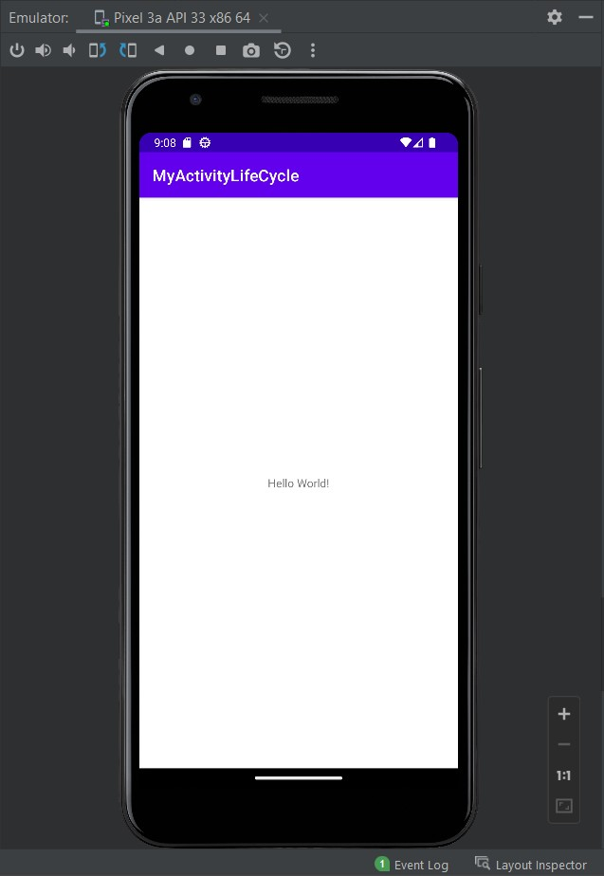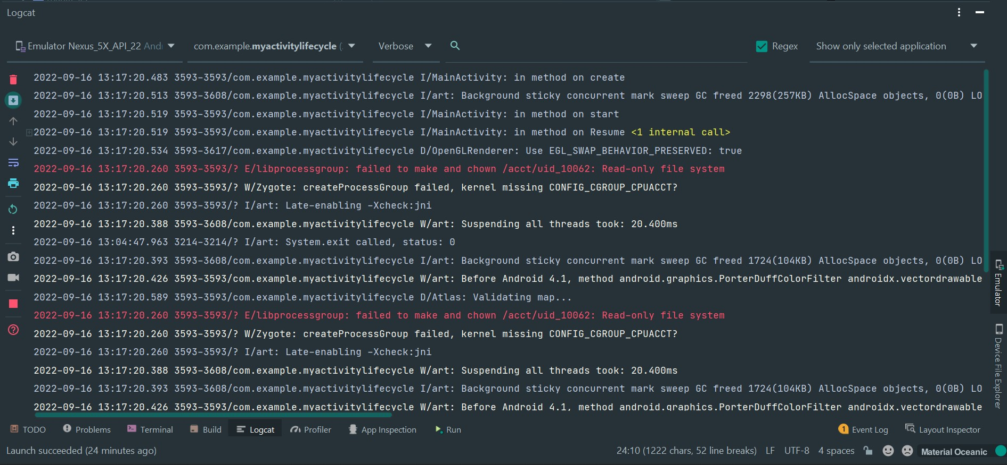

**Problem Statement 6-** Develop an Android Application to take the input of two numbers and display their sum

**Objective-** two numbers and print the result for the same.

# Activity_main.xml file

<?xml version="1.0" encoding="utf-8"?>

<RelativeLayoutxmlns:android="[http://schemas.android.com/apk/res/android"](http://schemas.android.com/apk/res/android) xmlns:app="<http://schemas.android.com/apk/res-auto>" xmlns:tools="<http://schemas.android.com/tools>" android:layout_width="match_parent"

android:layout_height="match_parent" tools:context=".MainActivity">

<TextView android:layout_width="wrap_content" android:layout_height="wrap_content"

app:layout_constraintBottom_toBottomOf="parent" app:layout_constraintEnd_toEndOf="parent" app:layout_constraintStart_toStartOf="parent" app:layout_constraintTop_toTopOf="parent" android:padding="20dp"

/>

<EditText android:layout_width="match_parent" android:layout_height="wrap_content" android:id="@+id/et1" android:layout_margin="80dp" android:inputType="number" android:textAlignment="center"/>

<EditText android:id="@+id/et2" android:layout_width="316dp"

android:layout_height="wrap_content" android:layout_below="@id/et1" android:layout_marginStart="80dp" android:layout_marginTop="30dp" android:layout_marginEnd="80dp" android:layout_marginBottom="30dp" android:textAlignment="center" android:inputType="number" />

<Button

android:id="@+id/b1" android:layout_width="100dp" android:layout_height="50dp" android:layout_below="@id/et2" android:layout_margin="60dp" android:layout_centerHorizontal="true" android:text="ADD" />

<TextView android:id="@+id/tv1"

android:layout_width="match_parent" android:layout_height="wrap_content" android:layout_below="@id/b1" android:layout_centerHorizontal="true" android:layout_marginStart="80dp" android:layout_marginTop="30dp" android:layout_marginEnd="80dp" android:layout_marginBottom="30dp" android:textSize="30dp" android:text="Result" android:textAlignment="center" />

</RelativeLayout>

# MainActivity.java

package com.example.my_applicationaccept;

import androidx.appcompat.app.AppCompatActivity; import android.os.Bundle;

import android.view.View;

import android.widget.Button; import android.widget.EditText; import android.widget.TextView;

public class MainActivity extends AppCompatActivity { Button bt1;

TextView tv; EditText et1,et2;

@Override

protected void onCreate(Bundle savedInstanceState) { super.onCreate(savedInstanceState); setContentView(R.layout.activity_main);

bt1=findViewById(R.id.b1);

tv=findViewById(R.id.tv1); et1=findViewById(R.id.et1); et2=findViewById(R.id.et2); bt1.setOnClickListener(new View.OnClickListener() {

@Override

public void onClick(View view) {

int num1=Integer.parseInt(et1.getText().toString()); int num2=Integer.parseInt(et2.getText().toString()); int sum=num1+num2;

tv.setText(String.valueOf(sum));

}

});

}

}

# AndroidManifest.xml file

<?xml version="1.0" encoding="utf-8"?>

<manifest xmlns:android="[http://schemas.android.com/apk/res/android"](http://schemas.android.com/apk/res/android) xmlns:tools="<http://schemas.android.com/tools>">

<application android:allowBackup="true"

android:dataExtractionRules="@xml/data_extraction_rules" android:fullBackupContent="@xml/backup_rules" android:icon="@mipmap/ic_launcher" android:label="@string/app_name" android:roundIcon="@mipmap/ic_launcher_round" android:supportsRtl="true" android:theme="@style/Theme.My_ApplicationAccept" tools:targetApi="31">

<activity android:name=".MainActivity" android:exported="true">

<intent-filter>

<action android:name="android.intent.action.MAIN" />

<category android:name="android.intent.category.LAUNCHER" />

</intent-filter>

<meta-data android:name="android.app.lib_name" android:value="" />

</activity>

</application>

</manifest>

**OUTPUT**

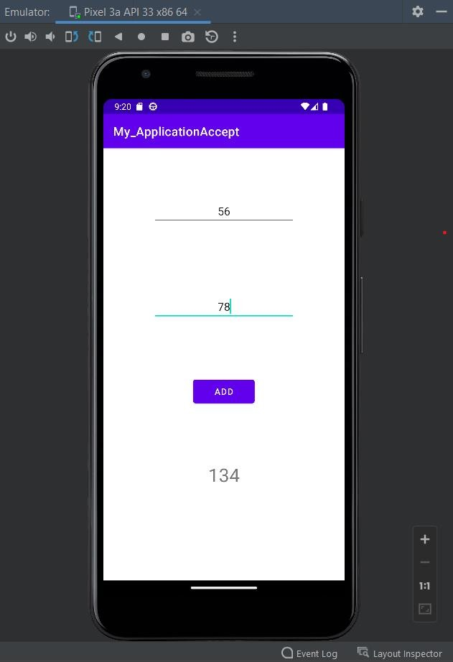

**Problem Statement 7-** Develop an Android Application to create a Simple Calculator

**Objective-** To design Calculator.

# Activity_main.xml file

<?xml version="1.0" encoding="utf-8"?>

<RelativeLayoutxmlns:android="[http://schemas.android.com/apk/res/android"](http://schemas.android.com/apk/res/android) xmlns:app="<http://schemas.android.com/apk/res-auto>" xmlns:tools="<http://schemas.android.com/tools>" android:layout_width="match_parent"

android:layout_height="match_parent" tools:context=".MainActivity">

<TextView android:layout_width="wrap_content" android:layout_height="wrap_content"

app:layout_constraintBottom_toBottomOf="parent" app:layout_constraintLeft_toLeftOf="parent" app:layout_constraintRight_toRightOf="parent" app:layout_constraintTop_toTopOf="parent" android:padding="30dp"/>

<EditText android:layout_width="match_parent" android:layout_height="wrap_content" android:id="@+id/et1"

android:layout_centerHorizontal="true" android:layout_margin="80dp" android:inputType="number" android:textAlignment="center"/>

<EditText android:id="@+id/et2" android:layout_width="400dp" android:layout_height="40dp" android:layout_below="@id/et1"

android:layout_centerHorizontal="true" android:layout_marginStart="10dp" android:layout_marginTop="150dp" android:layout_marginEnd="150dp" android:layout_marginBottom="150dp" android:inputType="number" android:textAlignment="center" />

<Button android:id="@+id/b1"

android:layout_width="match_parent"

android:layout_height="wrap_content" android:layout_below="@id/et1" android:layout_marginStart="90dp" android:layout_marginEnd="240dp" android:layout_marginTop="0dp" android:text="ADD" android:textAlignment="center"

/>

<Button android:id="@+id/b2"

android:layout_width="match_parent" android:layout_height="wrap_content" android:layout_below="@id/et1" android:layout_marginStart="240dp" android:layout_marginEnd="80dp" android:layout_marginTop="0dp" android:text="SUB" android:textAlignment="center"

/>

<Button android:id="@+id/b3"

android:layout_width="match_parent" android:layout_height="wrap_content" android:layout_below="@id/b1" android:layout_marginStart="90dp" android:layout_marginEnd="240dp" android:layout_marginTop="0dp" android:text="MUL" android:textAlignment="center"

/>

<Button android:id="@+id/b4"

android:layout_width="match_parent" android:layout_height="wrap_content" android:layout_below="@id/b2" android:layout_marginStart="240dp" android:layout_marginEnd="80dp" android:layout_marginTop="0dp" android:text="DIV" android:textAlignment="center"

/>

<TextView android:id="@+id/tv1" android:layout_width="200dp" android:layout_height="50dp" android:layout_below="@id/b1"

android:layout_centerHorizontal="true" android:layout_marginStart="10dp"

android:layout_marginTop="200dp" android:layout_marginBottom="80dp" android:text="Result" android:textAlignment="center" android:textSize="30dp" />

</RelativeLayout>

package com.example.calculatortwo;

# MainActivity.java

import androidx.appcompat.app.AppCompatActivity;

import android.os.Bundle; import android.view.View; import android.widget.Button; import android.widget.EditText;

import android.widget.TextView;

public class MainActivity extends AppCompatActivity { Button bt1,bt2,bt3,bt4;

TextView tv; EditText et1,et2;

@Override

protected void onCreate(Bundle savedInstanceState) { super.onCreate(savedInstanceState); setContentView(R.layout.activity_main);

bt1=findViewById(R.id.b1); bt2=findViewById(R.id.b2); bt3=findViewById(R.id.b3); bt4=findViewById(R.id.b4); tv=findViewById(R.id.tv1); et1=findViewById(R.id.et1); et2=findViewById(R.id.et2); bt1.setOnClickListener(new View.OnClickListener() {

@Override

public void onClick(View view) {

int num1=Integer.parseInt(et1.getText().toString()); int num2=Integer.parseInt(et2.getText().toString()); int sum=num1+num2;

tv.setText(String.valueOf(sum));

}

});

bt2.setOnClickListener(new View.OnClickListener() { @Override

public void onClick(View view) { int sum = 0;

int num1=Integer.parseInt(et1.getText().toString()); int num2=Integer.parseInt(et2.getText().toString()); if(num1>num2)

sum=num1-num2; else

sum=num2-num1; tv.setText(String.valueOf(sum));

}

});

bt3.setOnClickListener(new View.OnClickListener() { @Override

public void onClick(View view) {

int num1=Integer.parseInt(et1.getText().toString()); int num2=Integer.parseInt(et2.getText().toString()); int sum=num1*num2;

tv.setText(String.valueOf(sum));

}

});

bt4.setOnClickListener(new View.OnClickListener() { @Override

public void onClick(View view) {

int num1=Integer.parseInt(et1.getText().toString()); int num2=Integer.parseInt(et2.getText().toString()); int sum=num1/num2;

tv.setText(String.valueOf(sum));

}

});

}

}

# AndroidManifest.xml file

<?xml version="1.0" encoding="utf-8"?>

<manifest xmlns:android="[http://schemas.android.com/apk/res/android"](http://schemas.android.com/apk/res/android) xmlns:tools="<http://schemas.android.com/tools>">

<application android:allowBackup="true"

android:dataExtractionRules="@xml/data_extraction_rules" android:fullBackupContent="@xml/backup_rules" android:icon="@mipmap/ic_launcher" android:label="@string/app_name"

android:roundIcon="@mipmap/ic_launcher_round" android:supportsRtl="true" android:theme="@style/Theme.My_Calculator" tools:targetApi="31">

<activity android:name=".MainActivity" android:exported="true">

<intent-filter>

<action android:name="android.intent.action.MAIN" />

<category android:name="android.intent.category.LAUNCHER" />

</intent-filter>

<meta-data android:name="android.app.lib_name" android:value="" />

</activity>

</application>

</manifest>

**OUTPUT**

SUM SUBTRACT

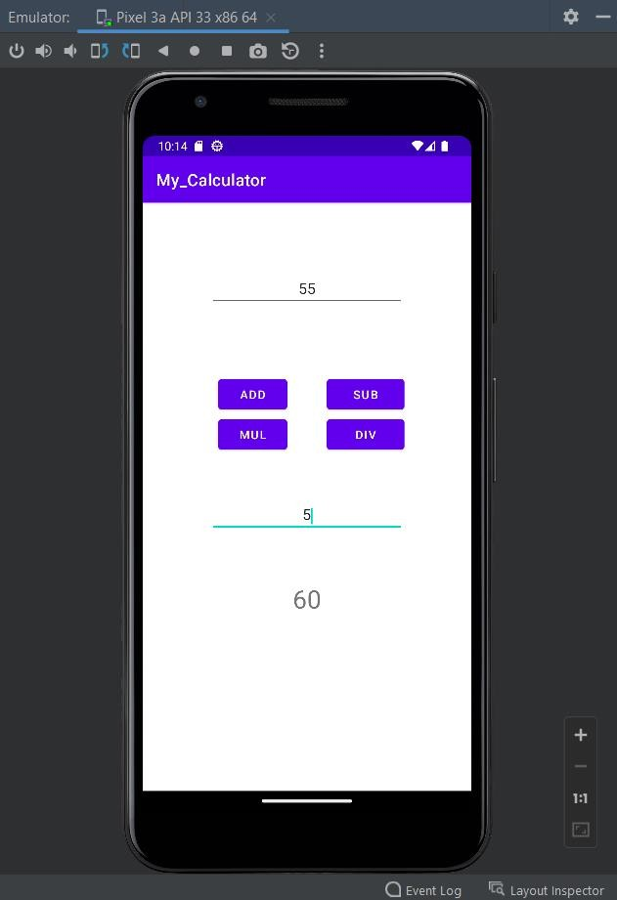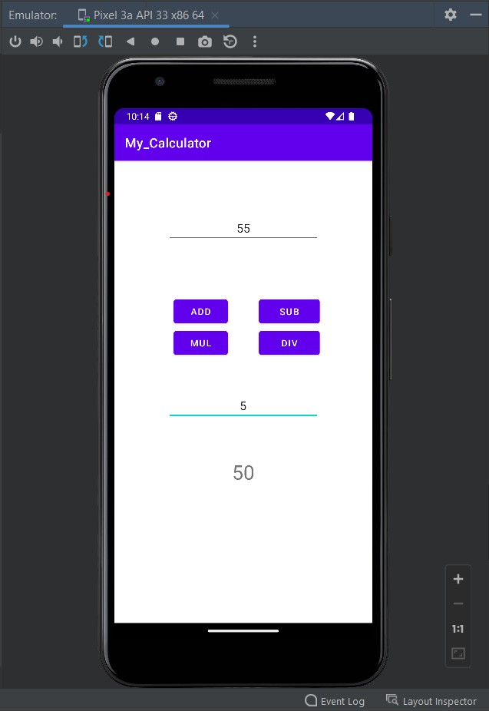

MULTIPLY DIVIDE

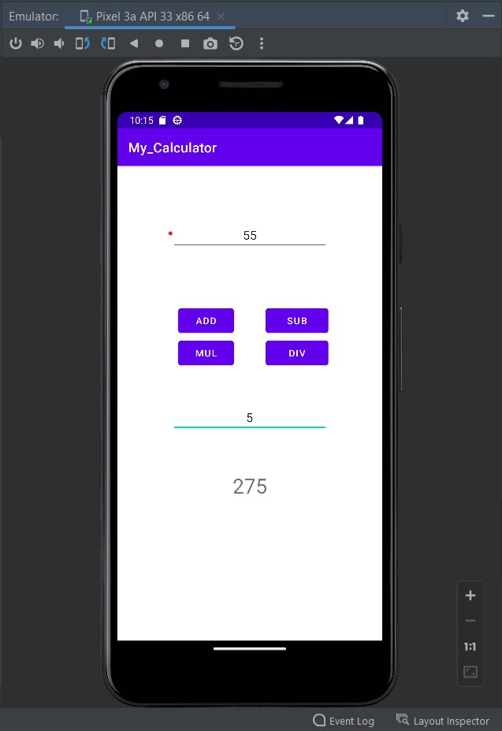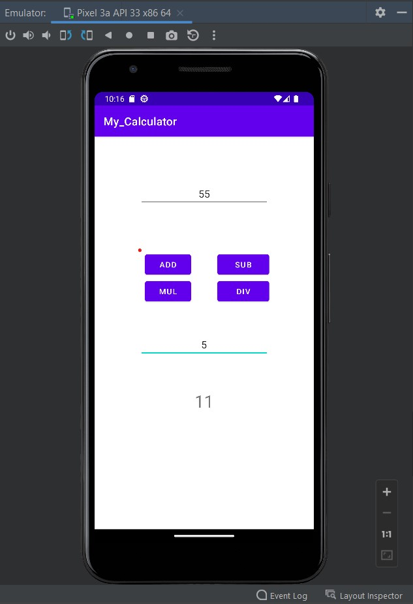

**Problem Statement 8-** Develop an Android Application to create two buttons having symbols “<” and “>” and also insert the image between these buttons and when clicked on buttons, image should get changed.

**Objective-**To change images between two buttons.

# Activity_main.xml file

<?xml version="1.0" encoding="utf-8"?>

<RelativeLayoutxmlns:android="[http://schemas.android.com/apk/res/android"](http://schemas.android.com/apk/res/android) xmlns:app="<http://schemas.android.com/apk/res-auto>" xmlns:tools="<http://schemas.android.com/tools>" android:layout_width="match_parent"

android:layout_height="match_parent" tools:context=".MainActivity">

<TextView android:layout_width="wrap_content" android:layout_height="wrap_content"

app:layout_constraintBottom_toBottomOf="parent" app:layout_constraintEnd_toEndOf="parent" app:layout_constraintStart_toStartOf="parent" app:layout_constraintTop_toTopOf="parent" />

<Button android:layout_width="100dp" android:layout_height="50dp" android:id="@+id/b1" android:layout_marginTop="150dp"

android:drawableTop="@drawable/next" android:layout_centerHorizontal="true"

/>

<Button android:layout_width="100dp" android:layout_height="50dp" android:id="@+id/b2" android:layout_centerHorizontal="true" android:layout_marginTop="500dp"

android:drawableTop="@drawable/previous"

/>

<ImageView android:layout_width="300sp" android:layout_height="300sp" android:id="@+id/iv" android:layout_centerInParent="true" android:background="#0ff" android:layout_below="@+id/b1"/>

</RelativeLayout>

# MainActivity.java

package com.example.my_imageapplication;

import androidx.appcompat.app.AppCompatActivity; import android.os.Bundle;

import android.view.View; import android.widget.Button;

import android.widget.ImageView;

public class MainActivity extends AppCompatActivity { @Override

protected void onCreate(Bundle savedInstanceState) { super.onCreate(savedInstanceState); setContentView(R.layout.activity_main);

Button bt1,bt2; ImageView iv1;

bt1 = findViewById(R.id.b1); bt2 = findViewById(R.id.b2); iv1 = findViewById(R.id.iv);

bt1.setOnClickListener(new View.OnClickListener() { @Override

public void onClick(View view) { iv1.setImageResource(R.drawable.flower);

}

});

bt2.setOnClickListener(new View.OnClickListener() { @Override

public void onClick(View view) { iv1.setImageResource(R.drawable.ice);

}

});

}

}

# AndroidManifest.xml file

<?xml version="1.0" encoding="utf-8"?>

<manifest xmlns:android="[http://schemas.android.com/apk/res/android"](http://schemas.android.com/apk/res/android) xmlns:tools="<http://schemas.android.com/tools>">

<application android:allowBackup="true"

android:dataExtractionRules="@xml/data_extraction_rules" android:fullBackupContent="@xml/backup_rules" android:icon="@mipmap/ic_launcher" android:label="@string/app_name"

android:roundIcon="@mipmap/ic_launcher_round" android:supportsRtl="true" android:theme="@style/Theme.My_ImageApplication" tools:targetApi="31">

<activity android:name=".MainActivity" android:exported="true">

<intent-filter>

<action android:name="android.intent.action.MAIN" />

<category android:name="android.intent.category.LAUNCHER" />

</intent-filter>

<meta-data android:name="android.app.lib_name" android:value="" />

</activity>

</application>

</manifest>

**OUTPUT**

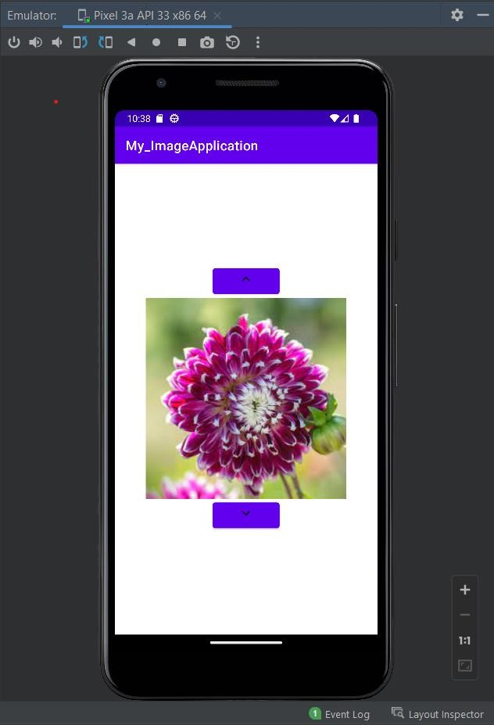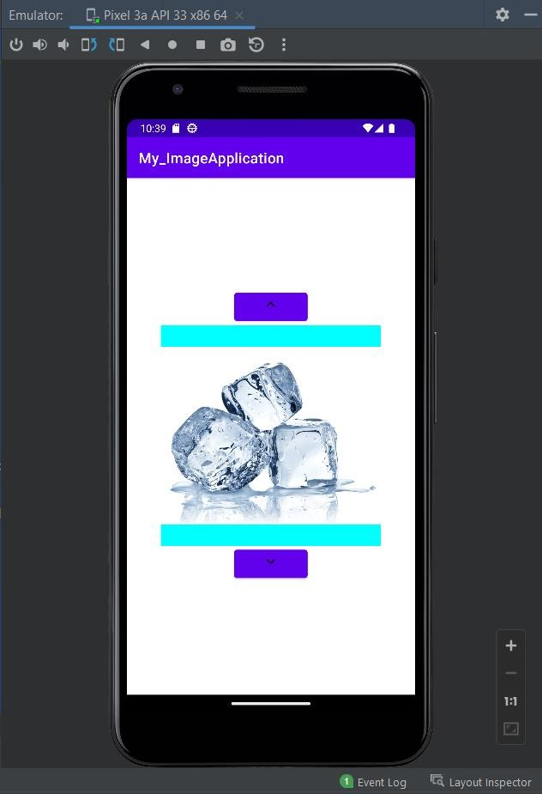

**Problem Statement 9-** Develop an android application to create a list of courses using Array Adapter.

**Objective-**To display list of courses

# Activity_main.xml file

<?xml version="1.0" encoding="utf-8"?>

<RelativeLayoutxmlns:android="[http://schemas.android.com/apk/res/android"](http://schemas.android.com/apk/res/android) xmlns:app="<http://schemas.android.com/apk/res-auto>" xmlns:tools="<http://schemas.android.com/tools>" android:layout_width="match_parent"

android:layout_height="match_parent" tools:context=".MainActivity">

<ListView android:id="@+id/list"

android:layout_width="match_parent" android:layout_height="match_parent"/>

</RelativeLayout>

# MainActivity.java

package com.example.my_list1;

import androidx.appcompat.app.AppCompatActivity;

import android.os.Bundle; import android.view.View;

import android.widget.AdapterView; import android.widget.ArrayAdapter; import android.widget.ListView; import android.widget.Toast;

public class MainActivity extends AppCompatActivity { ListView l;

String contents[] = {"BCA", "B.tech CS", "B.tech Mechanical", "BBA", "BSC IT", "BFA","BSC agriculture"};

@Override

protected void onCreate(Bundle savedInstanceState) { super.onCreate(savedInstanceState); setContentView(R.layout.activity_main);

l = findViewById(R.id.list);

ArrayAdapter<String>arrayAdapter = new ArrayAdapter<String>(this, android.R.layout.simple_list_item_1, contents); l.setAdapter(arrayAdapter);

l.setOnItemClickListener(new AdapterView.OnItemClickListener() {

@Override

public void onItemClick(AdapterView<?> parent, View view, int position, long id) { String clickedItem=(String) l.getItemAtPosition(position);

Toast.makeText(MainActivity.this,clickedItem, Toast.LENGTH_LONG).show();

}

});

}

}

# AndroidManifest.xml file

<?xml version="1.0" encoding="utf-8"?>

<manifest xmlns:android="[http://schemas.android.com/apk/res/android"](http://schemas.android.com/apk/res/android) xmlns:tools="<http://schemas.android.com/tools>">

<application android:allowBackup="true"

android:dataExtractionRules="@xml/data_extraction_rules" android:fullBackupContent="@xml/backup_rules" android:icon="@mipmap/ic_launcher" android:label="@string/app_name" android:roundIcon="@mipmap/ic_launcher_round" android:supportsRtl="true" android:theme="@style/Theme.My_List1" tools:targetApi="31">

<activity android:name=".MainActivity" android:exported="true">

<intent-filter>

<action android:name="android.intent.action.MAIN" />

<category android:name="android.intent.category.LAUNCHER" />

</intent-filter>

<meta-data android:name="android.app.lib_name" android:value="" />

</activity>

</application>

</manifest>

**OUTPUT**

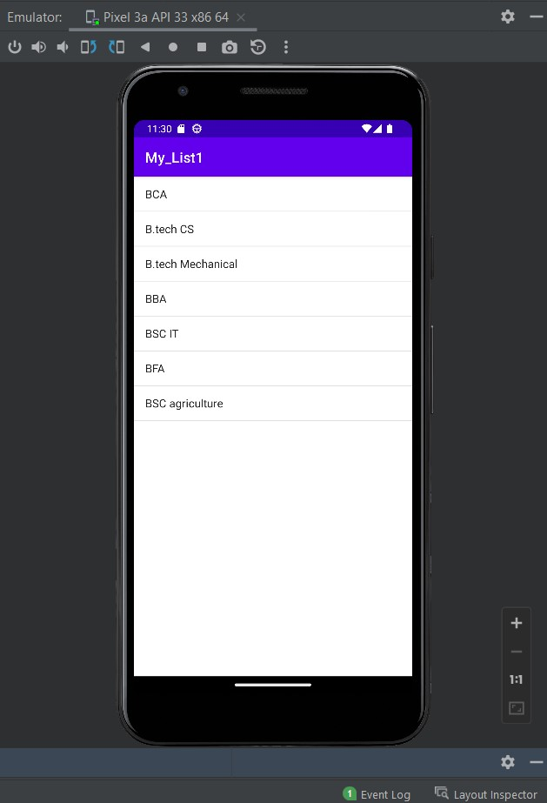

**Problem Statement 10-**Develop an android application to create a list to display the names and roll no. of students on the screen using Array Adapter.

**Objective-**To display list of names and roll no

# Activity_main.xml file

<?xml version="1.0" encoding="utf-8"?>

<RelativeLayoutxmlns:android="[http://schemas.android.com/apk/res/android"](http://schemas.android.com/apk/res/android) xmlns:app="<http://schemas.android.com/apk/res-auto>" xmlns:tools="<http://schemas.android.com/tools>" android:layout_width="match_parent"

android:layout_height="match_parent" tools:context=".MainActivity">

<Spinner android:id="@+id/spinner1"

android:layout_width="wrap_content" android:layout_height="wrap_content" android:layout_centerHorizontal="true" android:layout_marginTop="200dp"/>

</RelativeLayout>

# MainActivity.java

package com.example.my_list2;

import androidx.appcompat.app.AppCompatActivity;

import android.os.Bundle; import android.view.View;

import android.widget.AdapterView; import android.widget.ArrayAdapter; import android.widget.Spinner; import android.widget.Toast;

public class MainActivity extends AppCompatActivity implements AdapterView.OnItemSelectedListener { @Override

protected void onCreate(Bundle savedInstanceState) {

super.onCreate(savedInstanceState); setContentView(R.layout.activity_main);

Spinner spinner=findViewById(R.id.spinner1); ArrayAdapter<CharSequence> adapter = ArrayAdapter.createFromResource(this, R.array.numbers, android.R.layout.simple_spinner_item);

adapter.setDropDownViewResource(android.R.layout.simple_spinner_dropdown_item);

spinner.setAdapter(adapter); spinner.setOnItemSelectedListener(this);

}

@Override

public void onItemSelected(AdapterView<?> parent, View view, int position, long id) { String text = parent.getItemAtPosition(position).toString();

Toast.makeText(parent.getContext(), text, Toast.LENGTH_SHORT).show();

}

@Override

public void onNothingSelected(AdapterView<?> parent) {

}

}

# strings.xml

<resources>

<string name="app_name">My_List2</string>

<string-array name="numbers">

<item>Click</item>

<item>Rohan-55</item>

<item>Saloni-23</item>

<item>Kartikey-78</item>

<item>Amey-14</item>

<item>Akhil-20</item>

<item>Chiya-45</item>

</string-array>

</resources>

# AndroidManifest.xml file

<?xml version="1.0" encoding="utf-8"?>

<manifest xmlns:android="[http://schemas.android.com/apk/res/android"](http://schemas.android.com/apk/res/android) xmlns:tools="<http://schemas.android.com/tools>">

<application android:allowBackup="true"

android:dataExtractionRules="@xml/data_extraction_rules" android:fullBackupContent="@xml/backup_rules" android:icon="@mipmap/ic_launcher" android:label="@string/app_name" android:roundIcon="@mipmap/ic_launcher_round" android:supportsRtl="true" android:theme="@style/Theme.My_List2" tools:targetApi="31">

<activity

android:name=".MainActivity" android:exported="true">

<intent-filter>

<action android:name="android.intent.action.MAIN" />

<category android:name="android.intent.category.LAUNCHER" />

</intent-filter>

<meta-data android:name="android.app.lib_name" android:value="" />

</activity>

</application>

</manifest>

**OUTPUT**

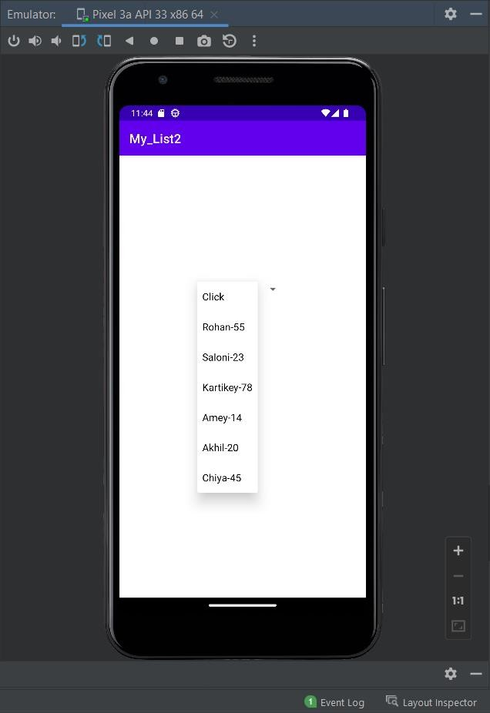

**Problem Statement 11**- Develop an android application to create 4 radio buttons of different colors. When user clicks on any of the button, the background color of the text-view should get changed.

**Objective-**To display radio buttons

# Activity_main.xml file

<?xml version="1.0" encoding="utf-8"?>

<RelativeLayoutxmlns:android="[http://schemas.android.com/apk/res/android"](http://schemas.android.com/apk/res/android) xmlns:app="<http://schemas.android.com/apk/res-auto>" xmlns:tools="<http://schemas.android.com/tools>" android:layout_width="match_parent"

android:layout_height="match_parent" tools:context=".MainActivity" android:id="@+id/rel">

<TextView android:layout_width="wrap_content" android:layout_height="wrap_content"

app:layout_constraintBottom_toBottomOf="parent" app:layout_constraintEnd_toEndOf="parent" app:layout_constraintStart_toStartOf="parent" app:layout_constraintTop_toTopOf="parent" />

<RadioGroup android:layout_width="match_parent" android:layout_height="match_parent" android:id="@+id/rg" android:orientation="vertical" >

<RadioButton android:layout_width="wrap_content" android:layout_height="wrap_content" android:id="@+id/blue" android:layout_marginStart="130dp" android:layout_marginTop="200dp" android:checked="true" android:text="blue" android:textSize="20dp" />

<RadioButton android:layout_width="wrap_content" android:layout_height="wrap_content" android:id="@+id/green" android:layout_marginStart="130dp" android:checked="false" android:text="green" android:textSize="20dp" android:layout_below="@+id/Paris" />

<RadioButton android:layout_width="wrap_content" android:layout_height="wrap_content" android:id="@+id/cyan" android:layout_marginStart="130dp" android:checked="false" android:text="cyan" android:textSize="20dp" android:layout_below="@+id/cyan" />

<RadioButton android:layout_width="wrap_content" android:layout_height="wrap_content" android:id="@+id/red" android:layout_marginStart="130dp" android:layout_below="@+id/red" android:checked="false" android:text="red" android:textSize="20dp" />

</RadioGroup>

<Button android:layout_width="100dp" android:layout_height="50dp" android:layout_centerHorizontal="true" android:layout_marginTop="550dp" android:text="Submit" android:id="@+id/submitButton" />

</RelativeLayout>

package com.example.my_radiobutton;

# MainActivity.java

import androidx.appcompat.app.AppCompatActivity;

import android.graphics.Color; import android.os.Bundle; import android.view.View; import android.widget.Button;

import android.widget.RadioButton; import android.widget.RelativeLayout;

public class MainActivity extends AppCompatActivity { RadioButtonblue,green,cyan,red;

Button submit;

RelativeLayoutrl; @Override

protected void onCreate(Bundle savedInstanceState) { super.onCreate(savedInstanceState); setContentView(R.layout.*activity_main*);

blue=findViewById(R.id.*blue*); green=findViewById(R.id.*green*); cyan=findViewById(R.id.*cyan*); red=findViewById(R.id.*red*); submit=findViewById(R.id.*submitButton*);

rl=findViewById(R.id.*rel*); submit.setOnClickListener(new View.OnClickListener() {

@Override

public void onClick(View view) { if(blue.isChecked())

{

rl.setBackgroundColor(Color.*BLUE*);

}

else if(green.isChecked()) { rl.setBackgroundColor(Color.*GREEN*);

}

else if(cyan.isChecked())

{

rl.setBackgroundColor(Color.*CYAN*);

}

else if(red.isChecked())

{

rl.setBackgroundColor(Color.*RED*);

}

}

});

}

}

# AndroidManifest.xml file

<?xml version="1.0" encoding="utf-8"?>

<manifest xmlns:android="[http://schemas.android.com/apk/res/android"](http://schemas.android.com/apk/res/android) xmlns:tools="<http://schemas.android.com/tools>">

<application android:allowBackup="true"

android:dataExtractionRules="@xml/data_extraction_rules" android:fullBackupContent="@xml/backup_rules" android:icon="@mipmap/ic_launcher" android:label="@string/app_name" android:roundIcon="@mipmap/ic_launcher_round"

android:supportsRtl="true" android:theme="@style/Theme.My_RadioButton" tools:targetApi="31">

<activity android:name=".MainActivity" android:exported="true">

<intent-filter>

<action android:name="android.intent.action.MAIN" />

<category android:name="android.intent.category.LAUNCHER" />

</intent-filter>

<meta-data android:name="android.app.lib_name" android:value="" />

</activity>

</application>

</manifest>

**OUTPUT**

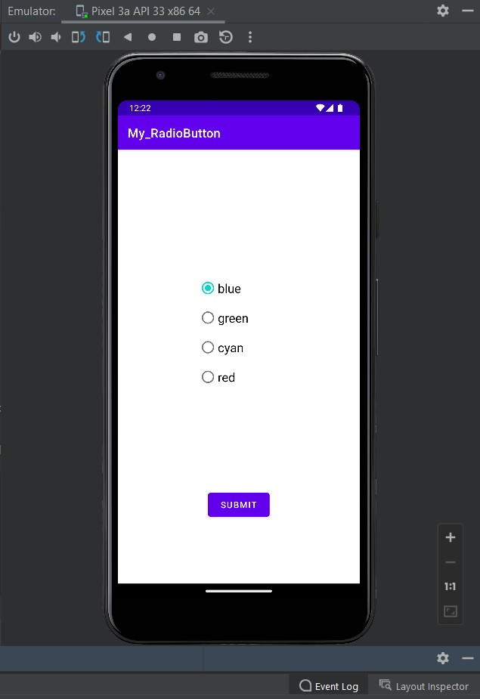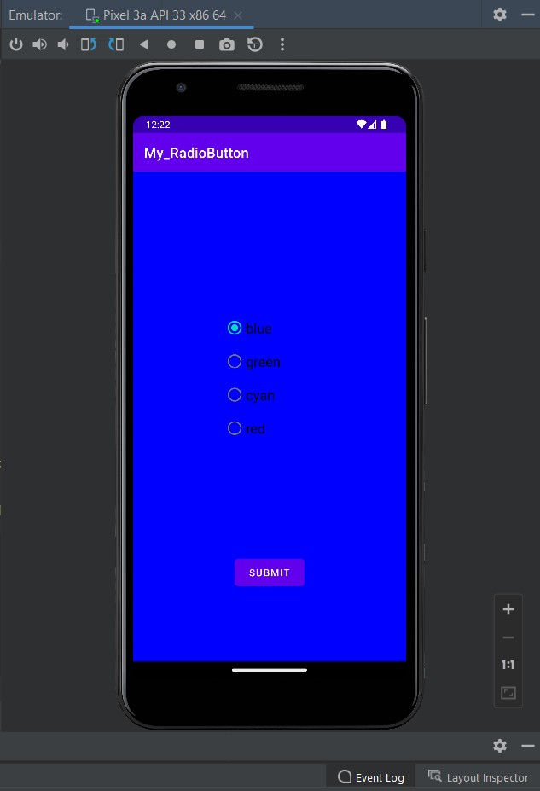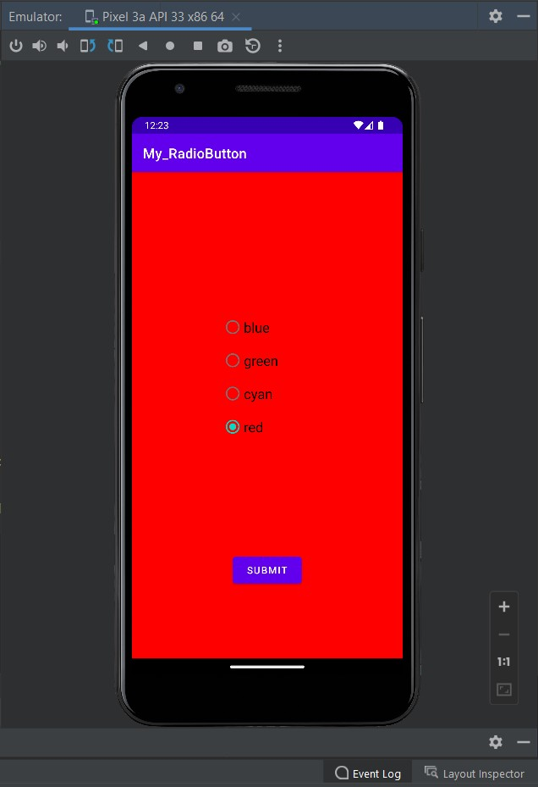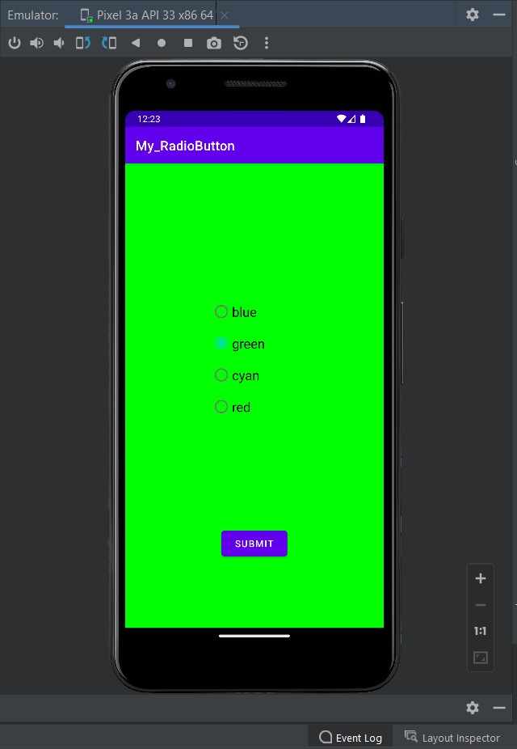

**Problem Statement 12**- Develop an android application to create the following activity:-A toast message should get displayed when the user clicks on the submit button.

**Objective-**To display toast message

# Activity_main.xml file

<?xml version="1.0" encoding="utf-8"?>

<RelativeLayoutxmlns:android="[http://schemas.android.com/apk/res/android"](http://schemas.android.com/apk/res/android) xmlns:app="<http://schemas.android.com/apk/res-auto>" xmlns:tools="<http://schemas.android.com/tools>" android:layout_width="match_parent"

android:layout_height="match_parent" tools:context=".MainActivity">

<TextView android:id="@+id/tv1"

android:layout_width="wrap_content" android:layout_height="wrap_content" android:layout_marginTop="26dp" android:textSize="22dp" android:textColor="@color/black" android:text="Name:" />

<EditText android:id="@+id/ed1"

android:layout_width="wrap_content" android:layout_height="wrap_content" android:layout_marginTop="16dp" android:layout_toRightOf="@+id/tv1" android:hint="Enter your name" android:textSize="18dp" />

<TextView android:id="@+id/tv2"

android:layout_width="wrap_content" android:layout_height="wrap_content" android:layout_below="@+id/tv1" android:layout_marginTop="17dp" android:text="Age:" android:textColor="@color/black" android:textSize="22dp" />

<EditText android:layout_width="wrap_content" android:layout_height="wrap_content" android:layout_below="@+id/ed1" android:layout_marginLeft="24dp" android:layout_toRightOf="@+id/tv2" android:hint="Enter your Age" android:id="@+id/ed2" android:textSize="18dp" />

<TextView android:id="@+id/tv3"

android:layout_width="wrap_content" android:layout_height="wrap_content" android:layout_below="@+id/tv2" android:layout_marginTop="17dp" android:text="Address:" android:textColor="@color/black" android:textSize="22dp" />

<EditText android:layout_width="wrap_content" android:layout_height="wrap_content" android:layout_below="@+id/ed2" android:id="@+id/ed3" android:layout_marginLeft="24dp" android:layout_toRightOf="@+id/tv3" android:hint="Enter your Address" android:textSize="18dp" />

<TextView android:id="@+id/tv4"

android:layout_width="wrap_content" android:layout_height="wrap_content" android:layout_below="@+id/tv3" android:layout_marginTop="17dp" android:text="Phone No.:" android:textColor="@color/black" android:textSize="22dp" />

<EditText android:layout_width="wrap_content" android:layout_height="wrap_content" android:layout_below="@+id/ed3" android:layout_marginLeft="24dp" android:layout_toRightOf="@+id/tv4" android:hint="Enter your Number" android:textSize="18dp" android:id="@+id/ed4"/>

<TextView android:id="@+id/tv5"

android:layout_width="wrap_content" android:layout_height="wrap_content" android:layout_below="@+id/tv4" android:layout_marginTop="17dp" android:text="Blood Group:" android:textColor="@color/black" android:textSize="22dp" />

<EditText android:layout_width="wrap_content" android:layout_height="wrap_content" android:layout_below="@+id/ed4"

android:id="@+id/ed5" android:layout_marginLeft="24dp" android:layout_toRightOf="@+id/tv5" android:hint="Enter your Blood Group" android:textSize="18dp" />

<Button android:id="@+id/bt1"

android:layout_width="wrap_content" android:layout_height="wrap_content" android:layout_alignParentEnd="true" android:layout_alignParentBottom="true" android:layout_marginEnd="196dp" android:layout_marginBottom="286dp" android:text="Submit" />

</RelativeLayout>

package com.example.my_toast;

# MainActivity.java

import androidx.appcompat.app.AppCompatActivity;

import android.os.Bundle; import android.view.View; import android.widget.Button; import android.widget.EditText; import android.widget.Toast;

public class MainActivity extends AppCompatActivity { Button bt;

EditText ed1;

EditText ed2,ed3,ed4,ed5; @Override

protected void onCreate(Bundle savedInstanceState) { super.onCreate(savedInstanceState); setContentView(R.layout.activity_main); bt=findViewById(R.id.bt1);

ed1=findViewById(R.id.ed1); ed2=findViewById(R.id.ed2); ed3=findViewById(R.id.ed3); ed4=findViewById(R.id.ed4); ed5=findViewById(R.id.ed5);

bt.setOnClickListener(new View.OnClickListener() { @Override

public void onClick(View view) { String name=ed1.getText().toString(); String age=ed2.getText().toString();

String add=ed3.getText().toString(); String No=ed4.getText().toString(); String Blood=ed5.getText().toString();

Toast.makeText(MainActivity.this,"Name:"+name+" Age:"+age+" Address:"+add+" Phone No:"+No+" Blood Group:"+Blood, Toast.LENGTH_LONG).show();

}

});

}

}

# AndroidManifest.xml file

<?xml version="1.0" encoding="utf-8"?>

<manifest xmlns:android="[http://schemas.android.com/apk/res/android"](http://schemas.android.com/apk/res/android) xmlns:tools="<http://schemas.android.com/tools>">

<application android:allowBackup="true"

android:dataExtractionRules="@xml/data_extraction_rules" android:fullBackupContent="@xml/backup_rules" android:icon="@mipmap/ic_launcher" android:label="@string/app_name" android:roundIcon="@mipmap/ic_launcher_round" android:supportsRtl="true" android:theme="@style/Theme.My_Toast" tools:targetApi="31">

<activity android:name=".MainActivity" android:exported="true">

<intent-filter>

<action android:name="android.intent.action.MAIN" />

<category android:name="android.intent.category.LAUNCHER" />

</intent-filter>

<meta-data android:name="android.app.lib_name" android:value="" />

</activity>

</application>

</manifest>

**OUTPUT**

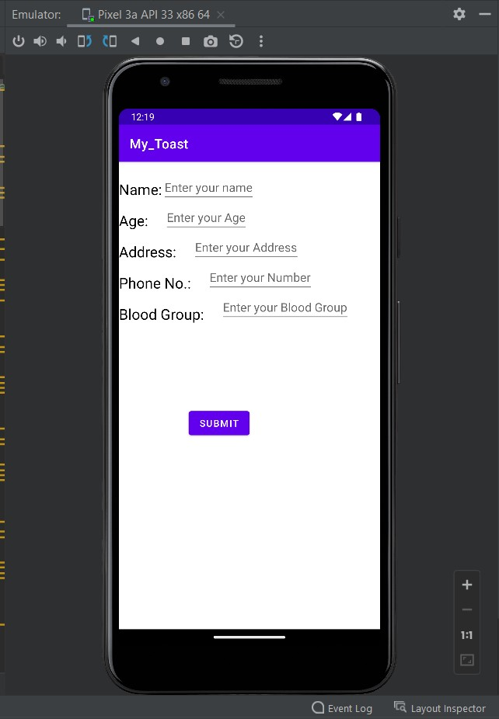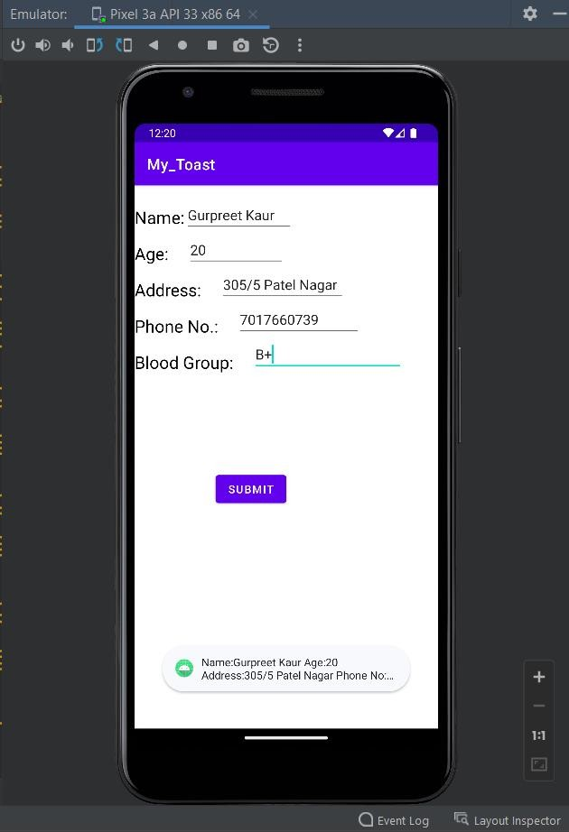

**Problem Statement 13-**Create an android application to create a Toggle Button having two values as ON and OFF and also insert a submit button. When the user clicks on Submit Button, then a Toast Message should generate displaying the state of the Toggle Button.

**Objective-**To display Toggle Button

<?xml version="1.0" encoding="utf-8"?>

# Activity_main.xml file

<RelativeLayoutxmlns:android="[http://schemas.android.com/apk/res/android"](http://schemas.android.com/apk/res/android) xmlns:app="<http://schemas.android.com/apk/res-auto>" xmlns:tools="<http://schemas.android.com/tools>" android:layout_width="match_parent"

android:layout_height="match_parent" tools:context=".MainActivity">

<ToggleButton android:layout_width="wrap_content" android:layout_height="wrap_content" android:id="@+id/toggleButton" android:text="ToggleButton" android:textOff="Off" android:textOn="On" android:layout_below="@+id/button" android:layout_centerHorizontal="true" android:layout_margin="70dp" android:textSize="30dp" />

<Button android:layout_width="wrap_content" android:layout_height="wrap_content" android:id="@+id/button" android:layout_margin="70dp" android:layout_centerHorizontal="true" android:text="Submit"/>

</RelativeLayout>

# MainActivity.java

package com.example.myapplication;

import androidx.appcompat.app.AppCompatActivity;

import android.os.Bundle; import android.view.View; import android.widget.Button; import android.widget.Toast;

import android.widget.ToggleButton;

public class MainActivity extends AppCompatActivity { ToggleButton toggleButton1;

Button buttonSubmit;

@Override

protected void onCreate(Bundle savedInstanceState) { super.onCreate(savedInstanceState); setContentView(R.layout.activity_main);

toggleButton1=findViewById(R.id.toggleButton); buttonSubmit=findViewById(R.id.button); buttonSubmit.setOnClickListener(new View.OnClickListener() {

@Override

public void onClick(View view) { String res;

res= toggleButton1.getText().toString(); Toast.makeText(getApplicationContext(),res,Toast.LENGTH_LONG).show();

}

});

}

}

# AndroidManifest.xml file

<?xml version="1.0" encoding="utf-8"?>

<manifest xmlns:android="[http://schemas.android.com/apk/res/android"](http://schemas.android.com/apk/res/android) xmlns:tools="<http://schemas.android.com/tools>">

<application android:allowBackup="true"

android:dataExtractionRules="@xml/data_extraction_rules" android:fullBackupContent="@xml/backup_rules" android:icon="@mipmap/ic_launcher" android:label="@string/app_name" android:roundIcon="@mipmap/ic_launcher_round" android:supportsRtl="true" android:theme="@style/Theme.My Application" tools:targetApi="31">

<activity android:name=".MainActivity" android:exported="true">

<intent-filter>

<action android:name="android.intent.action.MAIN" />

<category android:name="android.intent.category.LAUNCHER" />

</intent-filter>

<meta-data android:name="android.app.lib_name" android:value="" />

</activity>

</application>

</manifest>

**OUTPUT**

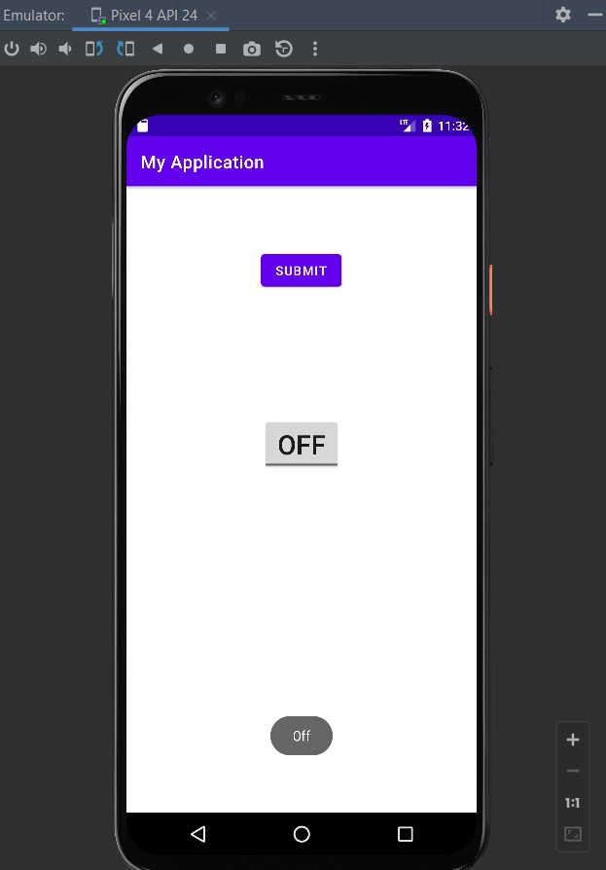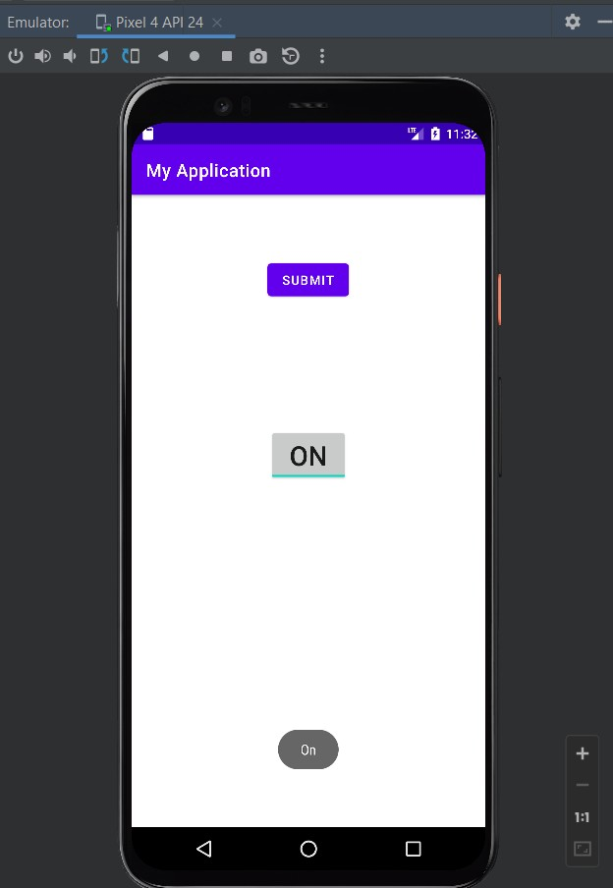

**Problem Statement 14**- Develop an android application to create an AutoCompleteTextView. When user enters the value in Text View, the AutoCompleteTextView should show the full value to be inserted.

**Objective-**To implement AutoCompleteTextView

# Activity_main.xml file

<?xml version="1.0" encoding="utf-8"?>

<RelativeLayoutxmlns:android="[http://schemas.android.com/apk/res/android"](http://schemas.android.com/apk/res/android) xmlns:app="<http://schemas.android.com/apk/res-auto>" xmlns:tools="<http://schemas.android.com/tools>" android:layout_width="match_parent"

android:layout_height="match_parent" tools:context=".MainActivity">

<AutoCompleteTextView android:id="@+id/autoComplete" android:layout_width="match_parent" android:layout_height="wrap_content" android:layout_marginLeft="20dp" android:layout_marginTop="100dp" android:layout_marginRight="20dp" android:completionThreshold="1" android:hint="Type here to search" android:padding="20dp" android:paddingLeft="5dp" android:textColor="@color/black">

</AutoCompleteTextView>

</RelativeLayout>

# MainActivity.java

package com.example.autocompletetextview;

import androidx.appcompat.app.AppCompatActivity; import android.os.Bundle;

import android.widget.ArrayAdapter;

import android.widget.AutoCompleteTextView;

public class MainActivity extends AppCompatActivity {

AutoCompleteTextViewautoCompleteTextView; ArrayAdapter<String>arrayAdapter;

String[]items={"How to use Android Studio","Android Studio codes in java","Main questions for exam"};

@Override

protected void onCreate(Bundle savedInstanceState) { super.onCreate(savedInstanceState); setContentView(R.layout.activity_main); autoCompleteTextView=findViewById(R.id.autoComplete);

arrayAdapter=new ArrayAdapter<String>(MainActivity.this, android.R.layout.simple_list_item_1,items); autoCompleteTextView.setAdapter(arrayAdapter);

}

}

# AndroidManifest.xml file

<?xml version="1.0" encoding="utf-8"?>

<manifest xmlns:android="[http://schemas.android.com/apk/res/android"](http://schemas.android.com/apk/res/android) xmlns:tools="<http://schemas.android.com/tools>"

package="com.example.autocompletetextview">

<application android:allowBackup="true"

android:dataExtractionRules="@xml/data_extraction_rules" android:fullBackupContent="@xml/backup_rules" android:icon="@mipmap/ic_launcher" android:label="@string/app_name" android:roundIcon="@mipmap/ic_launcher_round" android:supportsRtl="true" android:theme="@style/Theme.Autocompletetextview" tools:targetApi="31">

<activity android:name=".MainActivity" android:exported="true">

<intent-filter>

<action android:name="android.intent.action.MAIN" />

<category android:name="android.intent.category.LAUNCHER" />

</intent-filter>

</activity>

</application>

</manifest>

**OUTPUT**

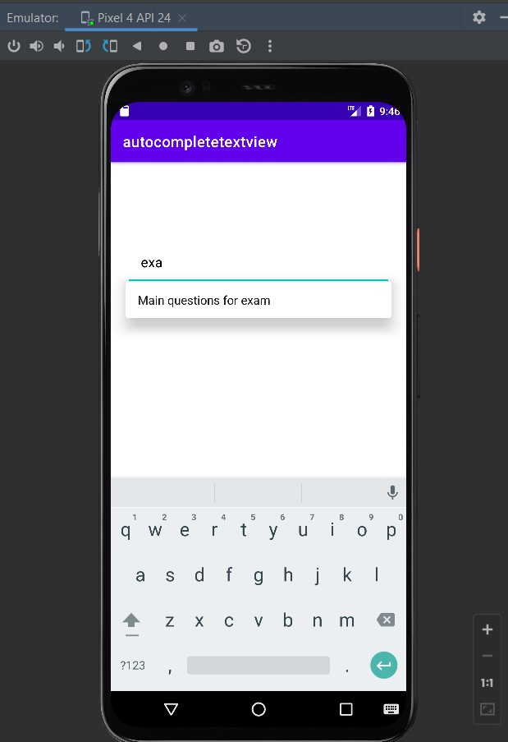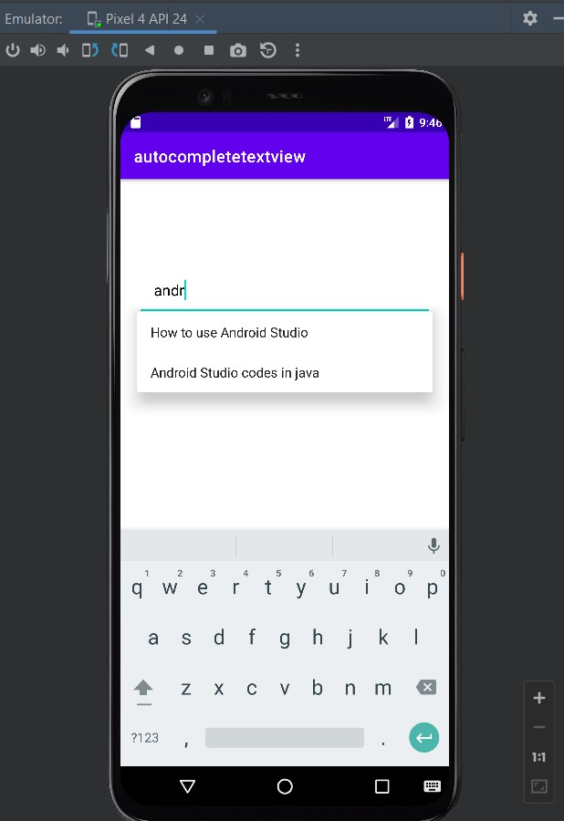

**Problem Statement 15** - Create an android application to demonstrate implicit intent.

**Objective-**To implement implicit intent

# Activity_main.xml file

<?xml version="1.0" encoding="utf-8"?>  
<RelativeLayout xmlns:android="http://schemas.android.com/apk/res/android"  
 xmlns:app="http://schemas.android.com/apk/res-auto"  
 xmlns:tools="http://schemas.android.com/tools"  
 android:layout_width="match_parent"  
 android:layout_height="match_parent"  
 tools:context=".MainActivity">  
  
 <EditText  
 android:id="@+id/et"  
 android:layout_width="match_parent"  
 android:layout_height="wrap_content" />  
 <Button  
 android:id="@+id/btn"  
 android:text="Search"  
 android:onClick="search"  
 android:layout_width="wrap_content"  
 android:layout_height="wrap_content"  
 android:layout_centerVertical="true"  
 android:layout_centerHorizontal="true"/>  
  
  
</RelativeLayout>

# MainActivity.java

package com.example.myapplication;  
  
import androidx.appcompat.app.AppCompatActivity;  
  
import android.content.Intent;  
import android.net.Uri;  
import android.os.Bundle;  
import android.view.View;  
import android.widget.Button;  
import android.widget.EditText;  
  
public class MainActivity extends AppCompatActivity {  
 EditText et;  
 Button btn;  
  
 @Override  
 protected void onCreate(Bundle savedInstanceState) {  
 super.onCreate(savedInstanceState);  
 setContentView(R.layout.*activity_main*);  
  
 btn = findViewById(R.id.*btn*);  
 et = (EditText) findViewById(R.id.*et*);  
  
 btn.setOnClickListener(new View.OnClickListener() {  
 @Override  
 public void onClick(View view) {  
 String url=et.getText().toString();  
 Intent intent = new Intent(Intent.*ACTION_VIEW*, Uri.*parse*(url));  
 startActivity(intent);  
 }  
 });  
  
 }  
}

# AndroidManifest.xml file

<?xml version="1.0" encoding="utf-8"?>  
<manifest xmlns:android="http://schemas.android.com/apk/res/android"  
 xmlns:tools="http://schemas.android.com/tools">  
  
 <application  
 android:allowBackup="true"  
 android:dataExtractionRules="@xml/data_extraction_rules"  
 android:fullBackupContent="@xml/backup_rules"  
 android:icon="@mipmap/ic_launcher"  
 android:label="@string/app_name"  
 android:roundIcon="@mipmap/ic_launcher_round"  
 android:supportsRtl="true"  
 android:theme="@style/Theme.MyApplication"  
 tools:targetApi="31">  
 <activity  
 android:name=".MainActivity"  
 android:exported="true">  
 <intent-filter>  
 <action android:name="android.intent.action.MAIN" />  
  
 <category android:name="android.intent.category.LAUNCHER" />  
 </intent-filter>  
  
 <meta-data  
 android:name="android.app.lib_name"  
 android:value="" />  
 </activity>  
 </application>  
  
</manifest>

**OUTPUT**

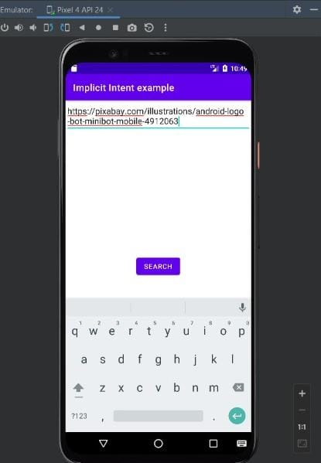 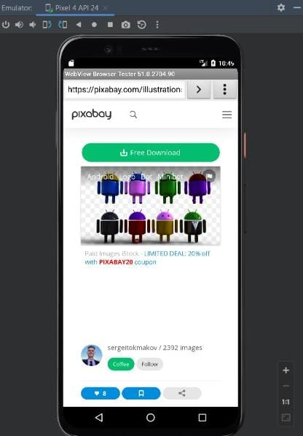

**Problem Statement 16** - Develop an android application to create image gallery using grid layout and intent

**Objective-**To implement GridView and Explicit intent

# Activity_main.xml file

<?xml version="1.0" encoding="utf-8"?>  
<LinearLayout xmlns:android="http://schemas.android.com/apk/res/android"  
 xmlns:app="http://schemas.android.com/apk/res-auto"  
 xmlns:tools="http://schemas.android.com/tools"  
 android:layout_width="match_parent"  
 android:layout_height="match_parent"  
 tools:context=".MainActivity"  
 android:orientation="vertical">  
  
 <GridView  
 android:id="@+id/g1"  
 android:layout_height="wrap_content"  
 android:layout_width="fill_parent"  
 android:padding="1dp"  
 android:numColumns="3"  
 />  
  
</LinearLayout>

# activity_gridview.xml

<?xml version="1.0" encoding="utf-8"?>  
<LinearLayout xmlns:android="http://schemas.android.com/apk/res/android"  
 android:layout_width="match_parent"  
 android:layout_height="wrap_content"  
 android:padding="1dp"  
 android:orientation="vertical">  
  
 <ImageView  
 android:id="@+id/icon"  
 android:layout_width="match_parent"  
 android:layout_height="120dp"  
 android:scaleType="fitXY"  
 android:layout_gravity="center_horizontal"  
 android:src="@drawable/logo1" />  
  
</LinearLayout>

# activity_second.xml

<?xml version="1.0" encoding="utf-8"?>  
<RelativeLayout xmlns:android="http://schemas.android.com/apk/res/android"  
 xmlns:tools="http://schemas.android.com/tools"  
 android:layout_width="match_parent"  
 android:layout_height="match_parent"  
 android:background="#fff"  
 tools:context="com.example.implicit.SecondActivity" >  
  
 <ImageView  
 android:id="@+id/selectedImage"  
 android:layout_width="match_parent"  
 android:layout_height="wrap_content"  
 android:layout_centerInParent="true"  
 android:scaleType="fitXY" />  
  
</RelativeLayout>

# MainActivity.java

package com.example.implicit;  
  
import androidx.appcompat.app.AppCompatActivity;  
import android.content.Intent;  
import android.os.Bundle;  
import android.view.View;  
import android.widget.AdapterView;  
import android.widget.GridView;  
  
  
public class MainActivity extends AppCompatActivity {  
 GridView gv1;  
  
 int logos[] = {R.drawable.*logo1*, R.drawable.*logo2*, R.drawable.*logo3*, R.drawable.*logo4*,  
 R.drawable.*logo5*, R.drawable.*logo6*, R.drawable.*logo7*, R.drawable.*logo8*, R.drawable.*logo9*,  
 R.drawable.*logo10*, R.drawable.*logo11*, R.drawable.*logo12*, R.drawable.*logo13*};  
  
 @Override  
 protected void onCreate(Bundle savedInstanceState) {  
 super.onCreate(savedInstanceState);  
 setContentView(R.layout.*activity_main*);  
  
 gv1=findViewById(R.id.*g1*);  
 CustomAdapter ca = new CustomAdapter(getApplicationContext(), logos);  
 gv1.setAdapter(ca);  
  
 gv1.setOnItemClickListener(new AdapterView.OnItemClickListener() {  
 @Override  
 public void onItemClick(AdapterView<?> adapterView, View view, int pos, long ID) {  
 Intent i=new Intent(MainActivity.this, SecondActivity.class);  
 i.putExtra("image", logos[pos]);  
 startActivity(i);  
 }  
 });  
 }  
}

# CustomAdapter.java

package com.example.implicit;  
  
import android.content.Context;  
import android.view.LayoutInflater;  
import android.view.View;  
import android.view.ViewGroup;  
import android.widget.BaseAdapter;  
import android.widget.ImageView;  
  
public class CustomAdapter extends BaseAdapter {  
 Context context;  
  
 int logos[];  
 LayoutInflater inflter;  
  
 public CustomAdapter(Context applicationContext, int[] logos) {  
 this.context = applicationContext;  
 this.logos = logos;  
 inflter = (LayoutInflater.*from*(applicationContext));  
 }  
  
 public int getCount() {  
 return logos.length;  
 }  
  
 public Object getItem(int i) {  
 return null;  
 }  
  
 public long getItemId(int i) {  
 return 0;  
 }  
  
 public View getView(int i, View view, ViewGroup viewGroup) {  
 view = inflter.inflate(R.layout.*activity_gridview*, null); // inflate the layout  
 ImageView icon = (ImageView) view.findViewById(R.id.*icon*); // get the reference of ImageView  
 icon.setImageResource(logos[i]); // set logo images  
 return view;  
 }  
}

# SecondActivity.java

package com.example.implicit;  
  
import android.content.Intent;  
import android.os.Bundle;  
import android.widget.ImageView;  
import androidx.appcompat.app.AppCompatActivity;  
  
public class SecondActivity extends AppCompatActivity {  
  
 ImageView iv;  
  
 @Override  
 public void onCreate(Bundle savedInstanceState) {  
 super.onCreate(savedInstanceState);  
  
 setContentView(R.layout.*activity_second*);  
 iv = findViewById(R.id.*selectedImage*); // init a ImageView  
 Intent intent = getIntent(); // get Intent which we set from Previous Activity  
 iv.setImageResource(intent.getIntExtra("image", 0)); // get image from Intent and set it in ImageView  
 }  
}

**OUTPUT**

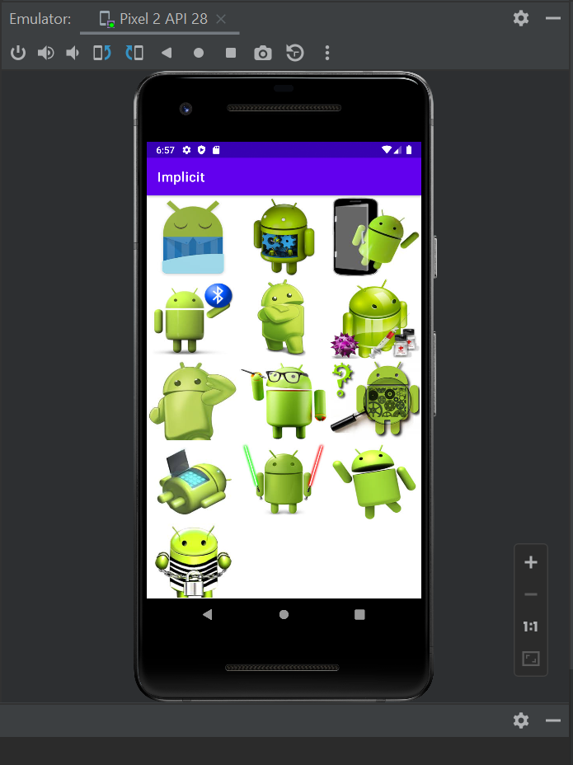 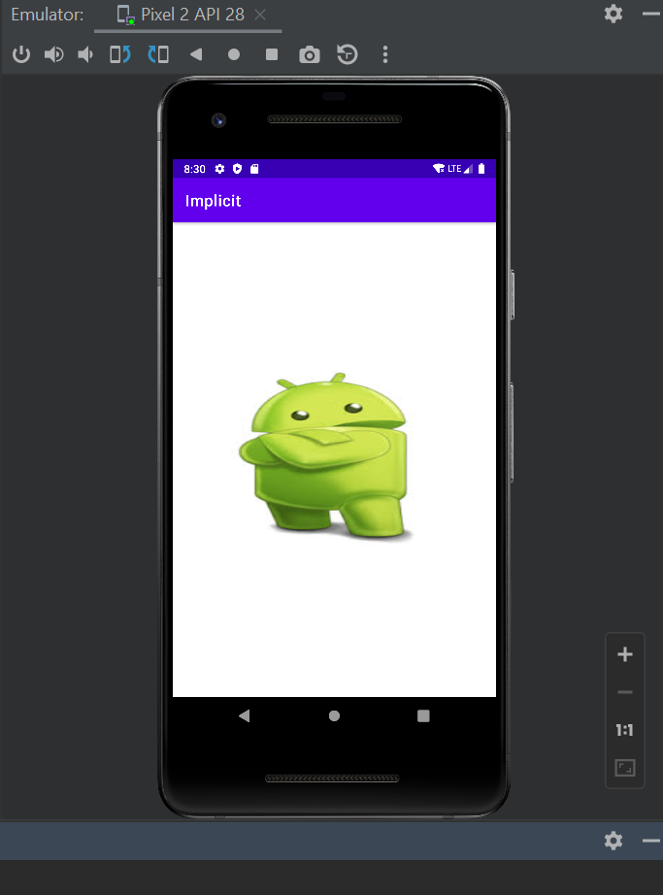

**Problem Statement 17** - Develop an android application to demonstrate the use of event listener and event handler

**Objective-**To implement setOnClickListener() and setOnLongClickListener()

# Activity_main.xml file

<?xml version="1.0" encoding="utf-8"?>  
<RelativeLayout xmlns:android="http://schemas.android.com/apk/res/android"  
 xmlns:app="http://schemas.android.com/apk/res-auto"  
 xmlns:tools="http://schemas.android.com/tools"  
 android:layout_width="match_parent"  
 android:layout_height="match_parent"  
 tools:context=".MainActivity">  
  
 <TextView  
 android:id="@+id/textview"  
 android:layout_width="match_parent"  
 android:layout_height="72dp"  
 android:layout_marginTop="20dp"  
 android:text="Hello !! World"  
 android:textAlignment="center"  
 android:textSize="30dp" />  
  
 <Button  
 android:id="@+id/button"  
 android:layout_width="171dp"  
 android:layout_height="59dp"  
 android:layout_below="@+id/textview"  
 android:layout_alignParentStart="true"  
 android:layout_alignParentEnd="true"  
 android:layout_marginStart="150dp"  
 android:layout_marginTop="224dp"  
 android:layout_marginEnd="150dp"  
 android:layout_marginBottom="150dp"  
 android:text="Click"  
 android:textAlignment="center"  
 android:textSize="20dp"/>  
  
</RelativeLayout>

# MainActivity.java

package com.example.my_eventhandler;  
  
import androidx.appcompat.app.AppCompatActivity;  
import android.graphics.Color;  
import android.os.Bundle;  
import android.view.View;  
import android.widget.Button;  
import android.widget.TextView;  
import android.widget.Toast;  
  
public class MainActivity extends AppCompatActivity {  
 Button b1;  
 TextView tv1;  
  
 @Override  
 protected void onCreate(Bundle savedInstanceState) {  
 super.onCreate(savedInstanceState);  
 setContentView(R.layout.*activity_main*);  
 b1=findViewById(R.id.*button*);  
 tv1=findViewById(R.id.*textview*);  
  
 b1.setOnClickListener(new View.OnClickListener() {  
 @Override  
 public void onClick(View view) {  
 Toast.*makeText*(MainActivity.this,"This is setOnClickListener",Toast.*LENGTH_SHORT*).show();

}  
 });  
 b1.setOnLongClickListener(new View.OnLongClickListener() {  
 @Override  
 public boolean onLongClick(View view) {  
 tv1.setBackgroundColor(Color.*RED*);  
 return false;  
 }  
 });  
 }  
}

# AndroidManifest.xml file

<?xml version="1.0" encoding="utf-8"?>  
<manifest xmlns:android="http://schemas.android.com/apk/res/android"  
 xmlns:tools="http://schemas.android.com/tools">  
  
 <application  
 android:allowBackup="true"  
 android:dataExtractionRules="@xml/data_extraction_rules"  
 android:fullBackupContent="@xml/backup_rules"  
 android:icon="@mipmap/ic_launcher"  
 android:label="@string/app_name"  
 android:roundIcon="@mipmap/ic_launcher_round"  
 android:supportsRtl="true"  
 android:theme="@style/Theme.My_EventHandler"  
 tools:targetApi="31">  
 <activity  
 android:name=".MainActivity"  
 android:exported="true">  
 <intent-filter>  
 <action android:name="android.intent.action.MAIN" />  
 <category android:name="android.intent.category.LAUNCHER" />  
 </intent-filter>  
  
 <meta-data  
 android:name="android.app.lib_name"  
 android:value="" />  
 </activity>  
 </application>  
  
</manifest>

**OUTPUT**

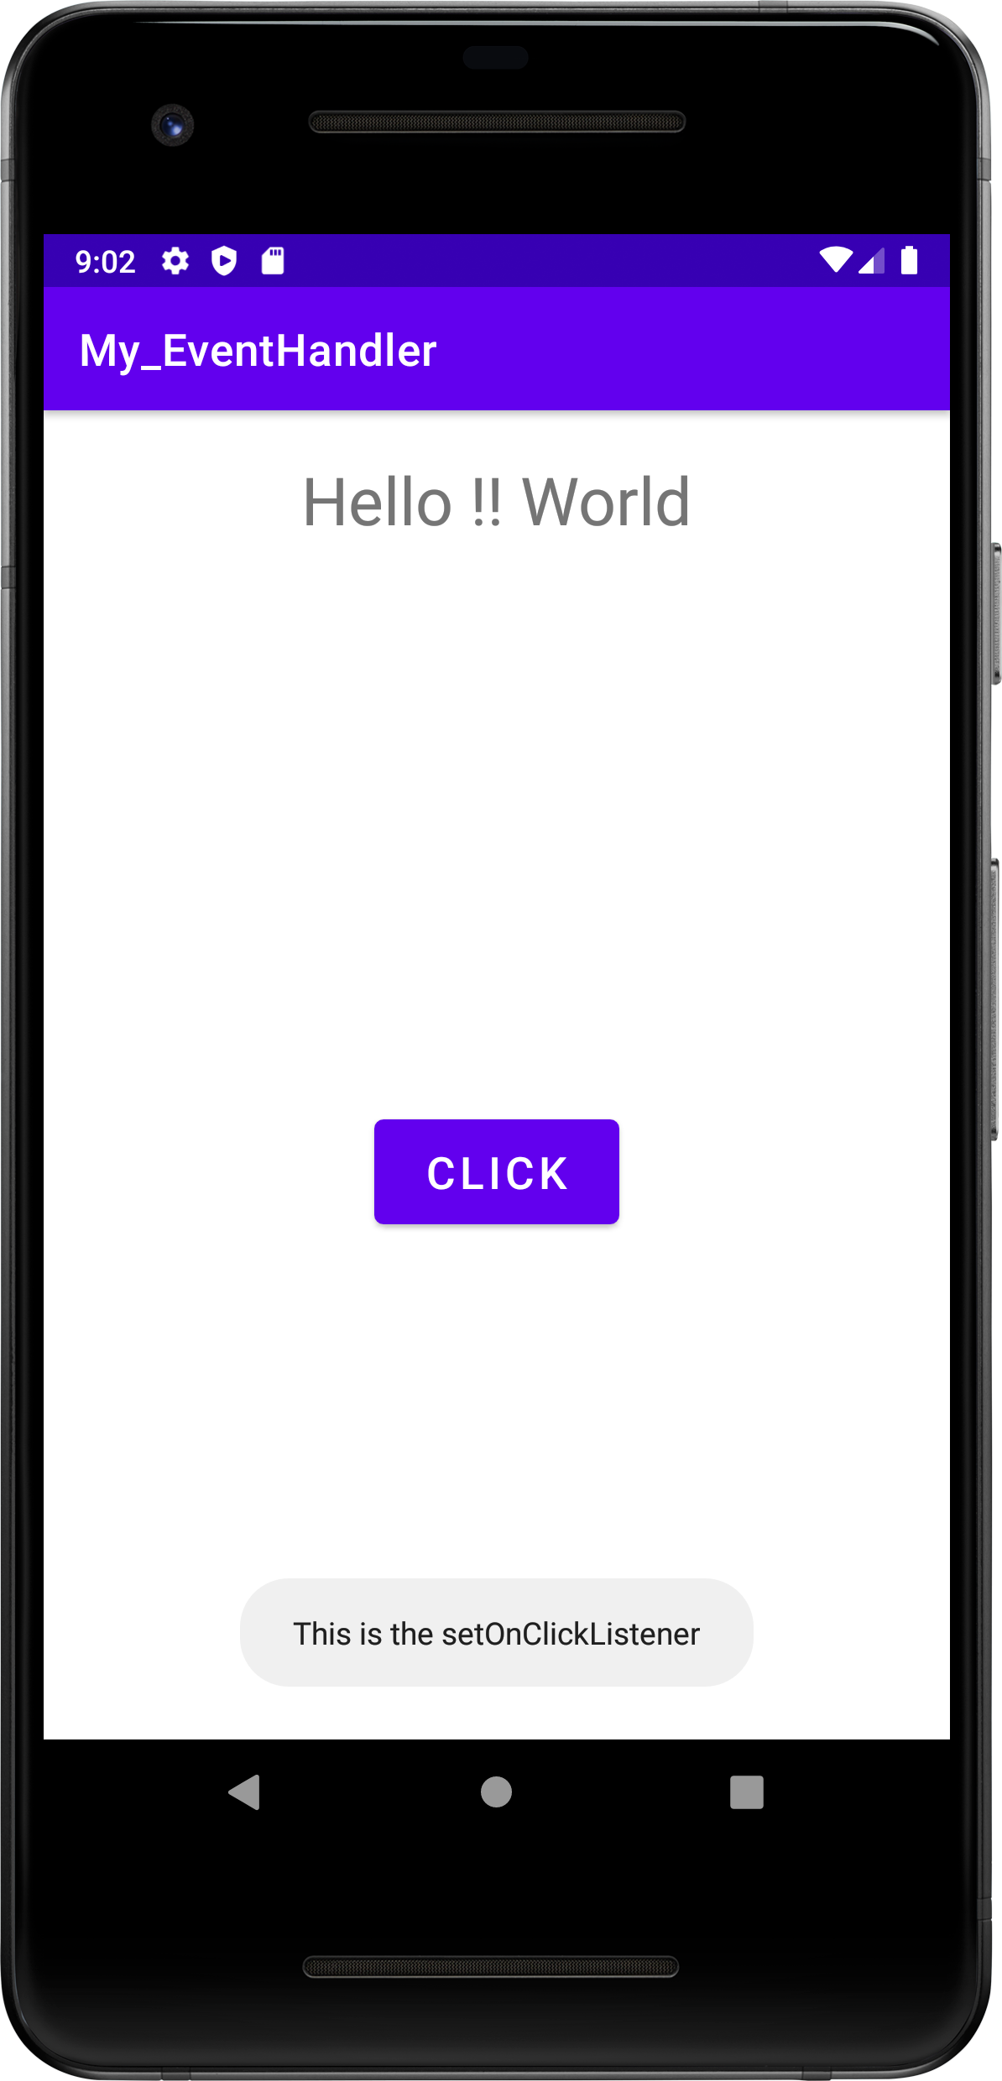 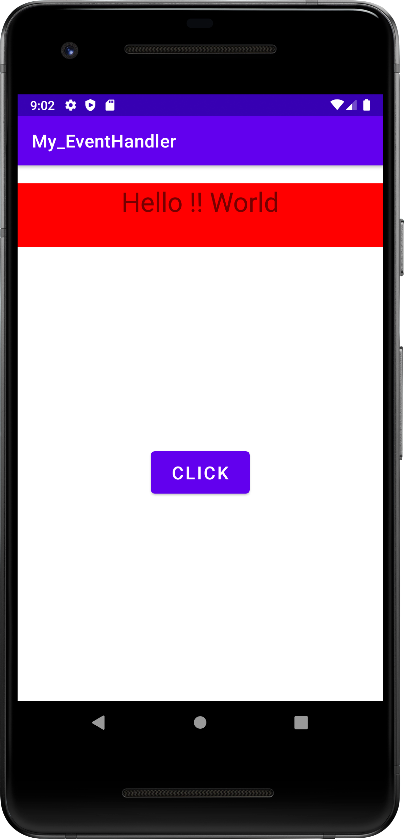

**Problem Statement 18** - Develop an android application to create a table layout

**Objective-** To use Table Layout

**Activity_main.xml file**

<?xml version="1.0" encoding="utf-8"?>  
<TableLayout xmlns:android="http://schemas.android.com/apk/res/android"  
 xmlns:app="http://schemas.android.com/apk/res-auto"  
 xmlns:tools="http://schemas.android.com/tools"  
 android:layout_width="match_parent"  
 android:layout_height="match_parent"  
 tools:context=".MainActivity">  
  
 <TableRow>  
  
 <TextView  
 android:layout_height="wrap_content"  
 android:layout_width="wrap_content"  
 android:text="row 1 col 1"  
 android:textSize="20dp"  
 android:padding="20dp"  
 android:background="#00ffff"  
 android:layout_margin="2dp"  
 />

<TextView  
 android:layout_height="wrap_content"  
 android:layout_width="wrap_content"  
 android:text="row 1 col 2"  
 android:background="#f5f5dc"  
 android:textSize="20dp"  
 android:padding="20dp"  
 android:layout_margin="2dp"/>

<TextView   
 android:layout_height="wrap_content"  
 android:layout_width="wrap_content"  
 android:text="row 1 col 3"  
 android:background="#8a2be2"  
 android:textSize="20dp"  
 android:padding="20dp"  
 android:layout_margin="2dp"/>  
  
 </TableRow>

<TableRow>  
 <TextView  
 android:layout_height="wrap_content"  
 android:layout_width="wrap_content"  
 android:text="row 2 col 1"  
 android:background="#00ffff"  
 android:textSize="20dp"  
 android:padding="20dp"  
 android:layout_span="2"  
 android:textAlignment="center"  
 android:layout_margin="2dp"  
 />  
  
 <TextView  
 android:layout_height="wrap_content"  
 android:layout_width="wrap_content"  
 android:text="row 2 col 2"  
 android:background="#f5f5dc"  
 android:textSize="20dp"  
 android:padding="20dp"  
 android:layout_margin="2dp"/>  
  
  
 </TableRow>  
 <TableRow>  
 <TextView   
 android:layout_height="wrap_content"  
 android:layout_width="wrap_content"  
 android:text="Row 3 col 1"  
 android:textSize="20dp"  
 android:padding="20dp"  
 android:layout_span="3"  
 android:background="#00ffff"  
 android:textAlignment="center"  
 android:layout_margin="2dp"  
 />  
 </TableRow>  
  
</TableLayout>

# MainActivity.java

package com.example.my_table1;  
  
import androidx.appcompat.app.AppCompatActivity;  
import android.os.Bundle;  
  
public class MainActivity extends AppCompatActivity {  
  
 @Override  
 protected void onCreate(Bundle savedInstanceState) {  
 super.onCreate(savedInstanceState);  
 setContentView(R.layout.*activity_main*);  
 }  
}

# AndroidManifest.xml file

<?xml version="1.0" encoding="utf-8"?>  
<manifest xmlns:android="http://schemas.android.com/apk/res/android"  
 xmlns:tools="http://schemas.android.com/tools">  
  
 <application  
 android:allowBackup="true"  
 android:dataExtractionRules="@xml/data_extraction_rules"  
 android:fullBackupContent="@xml/backup_rules"  
 android:icon="@mipmap/ic_launcher"  
 android:label="@string/app_name"  
 android:roundIcon="@mipmap/ic_launcher_round"  
 android:supportsRtl="true"  
 android:theme="@style/Theme.My_table1"  
 tools:targetApi="31">  
 <activity  
 android:name=".MainActivity"  
 android:exported="true">  
 <intent-filter>  
 <action android:name="android.intent.action.MAIN" />  
  
 <category android:name="android.intent.category.LAUNCHER" />  
 </intent-filter>  
  
 <meta-data  
 android:name="android.app.lib_name"  
 android:value="" />  
 </activity>  
 </application>  
  
</manifest>

**OUTPUT**

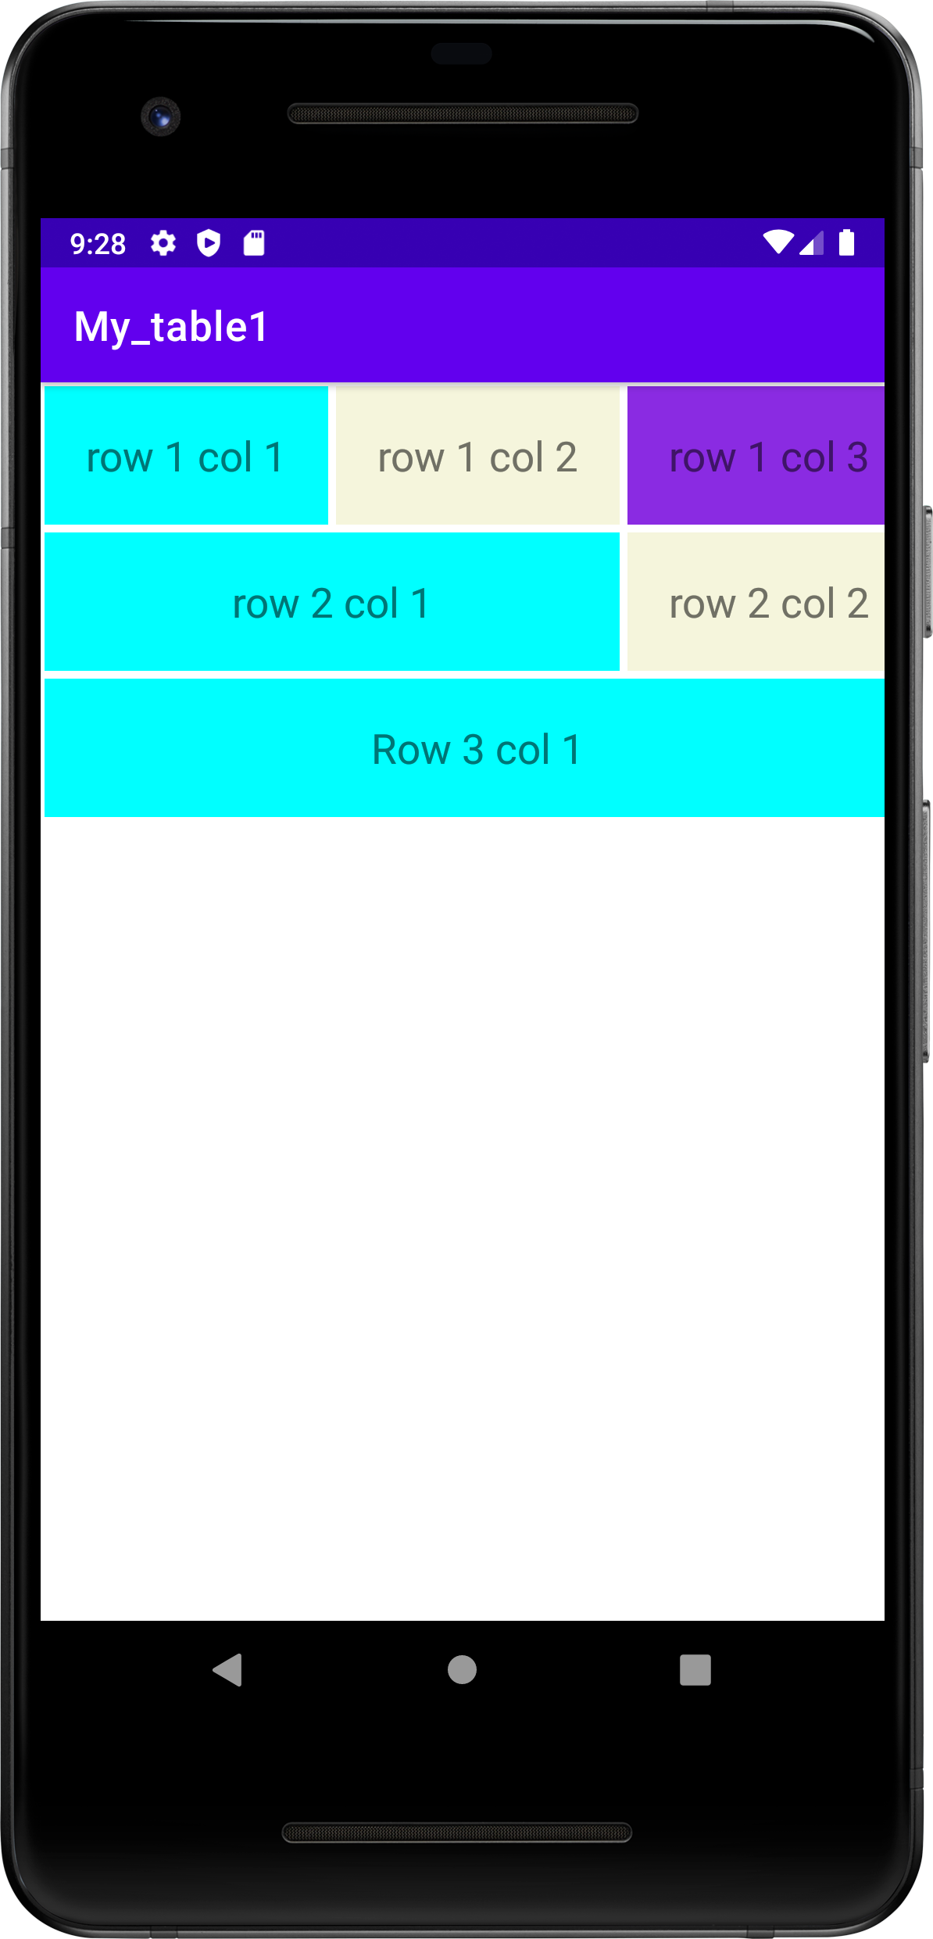

**Problem Statement 19** - Develop an android application to create a login form using table layout

**Objective-** To create login form

**Activity_main.xml file**

<?xml version="1.0" encoding="utf-8"?>  
<TableLayout xmlns:android="http://schemas.android.com/apk/res/android"  
 xmlns:app="http://schemas.android.com/apk/res-auto"  
 xmlns:tools="http://schemas.android.com/tools"  
 android:layout_width="match_parent"  
 android:layout_height="match_parent"  
 tools:context=".MainActivity">  
  
 <TableRow>  
  
 <TextView  
 android:layout_height="wrap_content"  
 android:layout_width="wrap_content"  
 android:text="row 1 col 1"  
 android:textSize="20dp"  
 android:padding="20dp"  
 android:background="#00ffff"  
 android:layout_margin="2dp"  
 />

<TextView  
 android:layout_height="wrap_content"  
 android:layout_width="wrap_content"  
 android:text="row 1 col 2"  
 android:background="#f5f5dc"  
 android:textSize="20dp"  
 android:padding="20dp"  
 android:layout_margin="2dp"/>

<TextView   
 android:layout_height="wrap_content"  
 android:layout_width="wrap_content"  
 android:text="row 1 col 3"  
 android:background="#8a2be2"  
 android:textSize="20dp"  
 android:padding="20dp"  
 android:layout_margin="2dp"/>  
  
 </TableRow>

<TableRow>  
 <TextView  
 android:layout_height="wrap_content"  
 android:layout_width="wrap_content"  
 android:text="row 2 col 1"  
 android:background="#00ffff"  
 android:textSize="20dp"  
 android:padding="20dp"  
 android:layout_span="2"  
 android:textAlignment="center"  
 android:layout_margin="2dp"  
 />  
  
 <TextView  
 android:layout_height="wrap_content"  
 android:layout_width="wrap_content"  
 android:text="row 2 col 2"  
 android:background="#f5f5dc"  
 android:textSize="20dp"  
 android:padding="20dp"  
 android:layout_margin="2dp"/>  
  
  
 </TableRow>  
 <TableRow>  
 <TextView   
 android:layout_height="wrap_content"  
 android:layout_width="wrap_content"  
 android:text="Row 3 col 1"  
 android:textSize="20dp"  
 android:padding="20dp"  
 android:layout_span="3"  
 android:background="#00ffff"  
 android:textAlignment="center"  
 android:layout_margin="2dp"  
 />  
 </TableRow>  
  
</TableLayout>

# MainActivity.java

package com.example.my_table2;  
  
import androidx.appcompat.app.AppCompatActivity;  
  
import android.os.Bundle;  
import android.view.View;  
import android.widget.Button;  
import android.widget.Toast;  
  
public class MainActivity extends AppCompatActivity {  
 Button b1;  
 @Override  
 protected void onCreate(Bundle savedInstanceState) {  
 super.onCreate(savedInstanceState);  
 setContentView(R.layout.*activity_main*);  
 b1=findViewById(R.id.*button*);  
 b1.setOnClickListener(new View.OnClickListener() {  
 @Override  
 public void onClick(View view) {  
 Toast.*makeText*(MainActivity.this,"Your Account has been Registered",Toast.*LENGTH_SHORT*).show();  
 }  
 });  
 }  
}

# AndroidManifest.xml file

<?xml version="1.0" encoding="utf-8"?>  
<manifest xmlns:android="http://schemas.android.com/apk/res/android"  
 xmlns:tools="http://schemas.android.com/tools">  
  
 <application  
 android:allowBackup="true"  
 android:dataExtractionRules="@xml/data_extraction_rules"  
 android:fullBackupContent="@xml/backup_rules"  
 android:icon="@mipmap/ic_launcher"  
 android:label="@string/app_name"  
 android:roundIcon="@mipmap/ic_launcher_round"  
 android:supportsRtl="true"  
 android:theme="@style/Theme.My_table2"  
 tools:targetApi="31">  
 <activity  
 android:name=".MainActivity"  
 android:exported="true">  
 <intent-filter>  
 <action android:name="android.intent.action.MAIN" />  
  
 <category android:name="android.intent.category.LAUNCHER" />  
 </intent-filter>  
  
 <meta-data  
 android:name="android.app.lib_name"  
 android:value="" />  
 </activity>  
 </application>  
  
</manifest>

**OUTPUT**

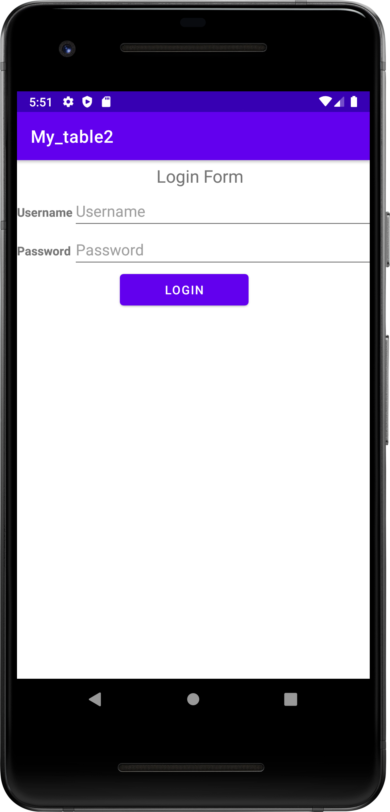 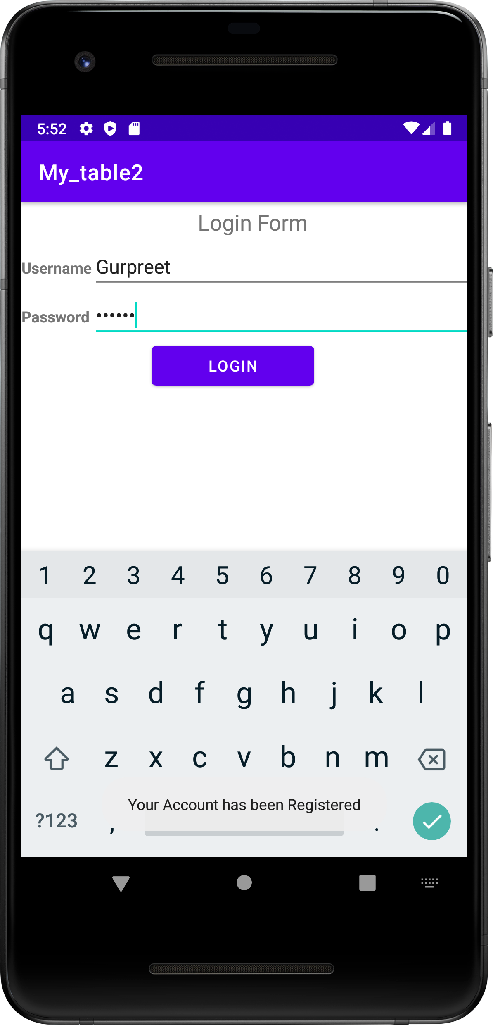

**Problem Statement 20**- Develop an android application to create a weather table using table layout

**Objective-** To create weather table using gif

**Activity_main.xml file**

<?xml version="1.0" encoding="utf-8"?>  
<TableLayout xmlns:android="http://schemas.android.com/apk/res/android"  
 xmlns:app="http://schemas.android.com/apk/res-auto"  
 xmlns:tools="http://schemas.android.com/tools"  
 android:layout_width="match_parent"  
 android:layout_height="match_parent"  
 tools:context=".MainActivity">  
  
 <TableRow  
 android:layout_width="match_parent"  
 android:layout_height="32dp">  
  
 <TextView  
 android:id="@+id/R1C1"  
 android:layout_width="match_parent"  
 android:layout_height="match_parent"  
 android:layout_span="7"  
 android:text="Weather Table"  
 android:textAlignment="center"/>  
  
 </TableRow>  
  
 <TableRow  
 android:layout_width="match_parent"  
 android:layout_height="wrap_content">  
  
 <TextView  
 android:layout_width="70dp"  
 android:layout_height="match_parent"/>  
 <TextView  
 android:layout_width="50dp"  
 android:layout_height="wrap_content"  
 android:text="Feb 7" />  
  
 <TextView  
 android:layout_width="50dp"  
 android:layout_height="wrap_content"  
 android:text="Feb 8"/>  
 <TextView  
 android:layout_width="50dp"  
 android:layout_height="wrap_content"  
 android:text="Feb9"/>  
 <TextView  
 android:layout_width="50dp"  
 android:layout_height="wrap_content"  
 android:text="Feb 10" />  
 <TextView  
 android:layout_width="50dp"  
 android:layout_height="wrap_content"  
 android:text="Feb 11" />  
 <TextView  
 android:layout_height="match_parent"  
 android:layout_width="70dp"/>  
  
 </TableRow>  
  
 <TableRow  
 android:layout_width="match_parent"  
 android:layout_height="wrap_content" >  
  
 <TextView  
 android:layout_width="70dp"  
 android:layout_height="match_parent"  
 android:text="Day High" />  
  
 <TextView  
 android:layout_width="70dp"  
 android:layout_height="match_parent"  
 android:text="Day High"/>  
  
 <TextView  
 android:layout_width="50dp"  
 android:layout_height="wrap_content"  
 android:text="28*F"/>  
  
 <TextView  
 android:layout_width="50dp"  
 android:layout_height="wrap_content"  
 android:text="26*F"/>  
  
 <TextView  
 android:layout_width="50dp"  
 android:layout_height="wrap_content"  
 android:text="23*F"/>  
  
 <TextView  
 android:layout_width="50dp"  
 android:layout_height="wrap_content"  
 android:text="17*F"/>  
  
 <TextView  
 android:layout_height="match_parent"  
 android:layout_width="70dp"  
 android:text="19*F"/>  
  
 <TextView  
 android:layout_width="70dp"  
 android:layout_height="match_parent"/>  
  
 </TableRow>  
  
 <TableRow  
 android:layout_width="match_parent"  
 android:layout_height="wrap_content"  
 >  
 <TextView  
 android:layout_width="70dp"  
 android:layout_height="match_parent"  
 android:text="Day Low" />  
  
 <TextView  
 android:layout_width="50dp"  
 android:layout_height="wrap_content"  
 android:text="15*F"/>  
 <TextView  
 android:layout_width="50dp"  
 android:layout_height="wrap_content"  
 android:text="14*F" />  
  
 <TextView  
 android:layout_width="50dp"  
 android:layout_height="wrap_content"  
 android:text="3*F" />  
  
 <TextView  
 android:layout_width="50dp"  
 android:layout_height="wrap_content"  
 android:text="5*F"/>  
  
 <TextView  
 android:layout_width="50dp"  
 android:layout_height="wrap_content"  
 android:text="6*F"/>  
  
 <TextView  
 android:layout_height="match_parent"  
 android:layout_width="70dp"/>  
 </TableRow>  
  
 <TableRow  
 android:layout_width="match_parent"  
 android:layout_height="wrap_content" >  
 <TextView  
 android:layout_width="70dp"  
 android:layout_height="match_parent"  
 android:text="Conditions"/>  
  
 <pl.droidsonroids.gif.GifImageView  
 android:layout_width="10dp"  
 android:layout_height="50dp"  
 android:src="@drawable/sun1"  
 />  
 <pl.droidsonroids.gif.GifImageView  
 android:layout_width="10dp"  
 android:layout_height="50dp"  
 android:src="@drawable/sun2"  
 />  
 <pl.droidsonroids.gif.GifImageView  
 android:layout_width="10dp"  
 android:layout_height="50dp"  
 android:src="@drawable/sun3"  
 />  
 <pl.droidsonroids.gif.GifImageView  
 android:layout_width="10dp"  
 android:layout_height="50dp"  
 android:src="@drawable/sun4"  
 />  
 <pl.droidsonroids.gif.GifImageView  
 android:layout_width="10dp"  
 android:layout_height="50dp"  
 android:src="@drawable/sun5"  
 />  
  
 <TextView  
 android:layout_width="70dp"  
 android:layout_height="match_parent"/>  
 </TableRow>  
</TableLayout>

# MainActivity.java

package com.example.my_table3;  
  
import androidx.appcompat.app.AppCompatActivity;  
  
import android.os.Bundle;  
  
public class MainActivity extends AppCompatActivity {  
  
 @Override  
 protected void onCreate(Bundle savedInstanceState) {  
 super.onCreate(savedInstanceState);  
 setContentView(R.layout.*activity_main*);  
 }  
}

# AndroidManifest.xml file

<?xml version="1.0" encoding="utf-8"?>  
<manifest xmlns:android="http://schemas.android.com/apk/res/android"  
 xmlns:tools="http://schemas.android.com/tools">  
  
 <application  
 android:allowBackup="true"  
 android:dataExtractionRules="@xml/data_extraction_rules"  
 android:fullBackupContent="@xml/backup_rules"  
 android:icon="@mipmap/ic_launcher"  
 android:label="@string/app_name"  
 android:roundIcon="@mipmap/ic_launcher_round"  
 android:supportsRtl="true"  
 android:theme="@style/Theme.My_table3"  
 tools:targetApi="31">  
 <activity  
 android:name=".MainActivity"  
 android:exported="true">  
 <intent-filter>  
 <action android:name="android.intent.action.MAIN" />  
  
 <category android:name="android.intent.category.LAUNCHER" />  
 </intent-filter>  
  
 <meta-data  
 android:name="android.app.lib_name"  
 android:value="" />  
 </activity>  
 </application>  
  
</manifest>

# build.gradle(:app)

plugins **{** id 'com.android.application'  
**}**android **{** namespace 'com.example.my_table3'  
 compileSdk 32  
  
 defaultConfig **{** applicationId "com.example.my_table3"  
 minSdk 21  
 targetSdk 32  
 versionCode 1  
 versionName "1.0"  
  
 testInstrumentationRunner "androidx.test.runner.AndroidJUnitRunner"  
 **}** buildTypes **{** release **{** minifyEnabled false  
 proguardFiles getDefaultProguardFile('proguard-android-optimize.txt'), 'proguard-rules.pro'  
 **}  
 }** compileOptions **{** sourceCompatibility JavaVersion.*VERSION_1_8* targetCompatibility JavaVersion.*VERSION_1_8* **}  
}**dependencies **{** implementation 'androidx.appcompat:appcompat:1.5.1'  
 implementation 'com.google.android.material:material:1.7.0'  
 implementation 'androidx.constraintlayout:constraintlayout:2.1.4'  
 testImplementation 'junit:junit:4.13.2'  
 androidTestImplementation 'androidx.test.ext:junit:1.1.4'  
 androidTestImplementation 'androidx.test.espresso:espresso-core:3.5.0'  
 implementation 'pl.droidsonroids.gif:android-gif-drawable:1.2.19'  
**}**

**OUTPUT**

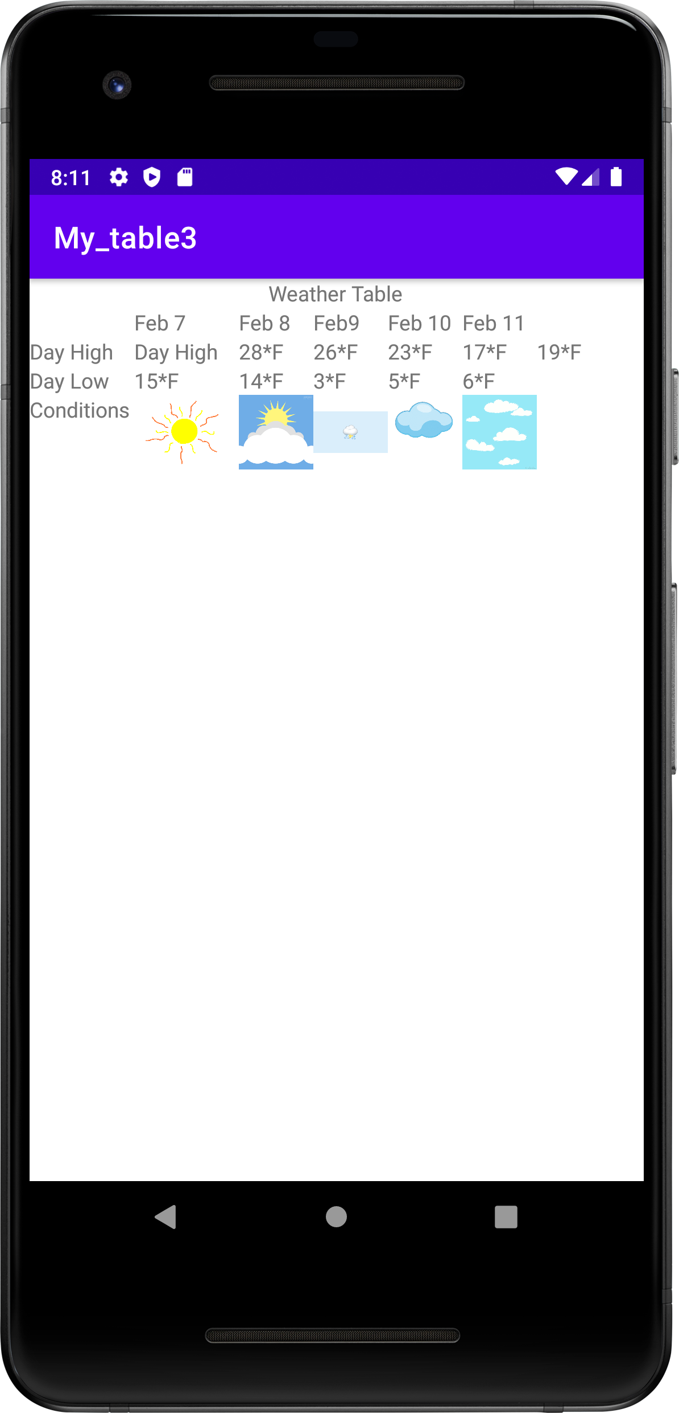

**Problem Statement 21-** Develop an android application to create an audio media player

**Objective-** To create media player

**Activity_main.xml file**

<?xml version="1.0" encoding="utf-8"?>  
<RelativeLayout xmlns:android="http://schemas.android.com/apk/res/android"  
 xmlns:app="http://schemas.android.com/apk/res-auto"  
 xmlns:tools="http://schemas.android.com/tools"  
 android:layout_width="match_parent"  
 android:layout_height="match_parent"  
 tools:context=".MainActivity">  
  
 <Button  
 android:layout_width="132dp"  
 android:layout_height="wrap_content"  
 android:layout_marginStart="142dp"  
 android:layout_marginTop="252dp"  
 android:onClick="play"  
 android:text="Start" />  
 <Button  
 android:layout_width="132dp"  
 android:layout_height="wrap_content"  
 android:text="Pause"  
 android:layout_marginTop="302dp"  
 android:layout_marginStart="142dp"  
 android:onClick="pause"/>  
  
 <Button  
 android:layout_width="132dp"  
 android:layout_height="wrap_content"  
 android:text="Stop"  
 android:layout_marginTop="345dp"  
 android:layout_marginStart="142dp"  
 android:onClick="stop"/>  
  
  
</RelativeLayout>

# MainActivity.java

package com.example.my_mediaplayer;  
  
import androidx.appcompat.app.AppCompatActivity;  
  
import android.media.MediaPlayer;  
import android.os.Bundle;  
import android.view.View;  
import android.widget.Toast;  
  
public class MainActivity extends AppCompatActivity {  
 MediaPlayer player;  
 @Override  
 protected void onCreate(Bundle savedInstanceState) {  
 super.onCreate(savedInstanceState);  
 setContentView(R.layout.*activity_main*);  
 }  
  
 public void play(View v){  
 if(player == null){  
 player = MediaPlayer.*create*(this, R.raw.*song*);  
 player.setOnCompletionListener(new MediaPlayer.OnCompletionListener() {  
 @Override  
 public void onCompletion(MediaPlayer mediaPlayer) {  
 stopPlayer();  
 }  
 });  
 }  
 player.start();  
 }  
  
 public void pause(View v){  
 if (player != null) {  
 player.pause();  
 }  
 }  
  
 public void stop(View v){  
 stopPlayer();  
 }  
 private void stopPlayer() {  
 if(player !=null) {  
 player.release();  
 player =null;  
 Toast.*makeText*(this, "MediaPlayer Stopped", Toast.*LENGTH_SHORT*).show();  
 }  
 }  
  
 @Override  
 protected void onStop() {  
 super.onStop();  
 stopPlayer();  
 }  
}

# AndroidManifest.xml file

<?xml version="1.0" encoding="utf-8"?>  
<manifest xmlns:android="http://schemas.android.com/apk/res/android"  
 xmlns:tools="http://schemas.android.com/tools">  
  
 <application  
 android:allowBackup="true"  
 android:dataExtractionRules="@xml/data_extraction_rules"  
 android:fullBackupContent="@xml/backup_rules"  
 android:icon="@mipmap/ic_launcher"  
 android:label="@string/app_name"  
 android:roundIcon="@mipmap/ic_launcher_round"  
 android:supportsRtl="true"  
 android:theme="@style/Theme.My_MediaPlayer"  
 tools:targetApi="31">  
 <activity  
 android:name=".MainActivity"  
 android:exported="true">  
 <intent-filter>  
 <action android:name="android.intent.action.MAIN" />  
  
 <category android:name="android.intent.category.LAUNCHER" />  
 </intent-filter>  
  
 <meta-data  
 android:name="android.app.lib_name"  
 android:value="" />  
 </activity>  
 </application>  
  
</manifest>

**OUTPUT**

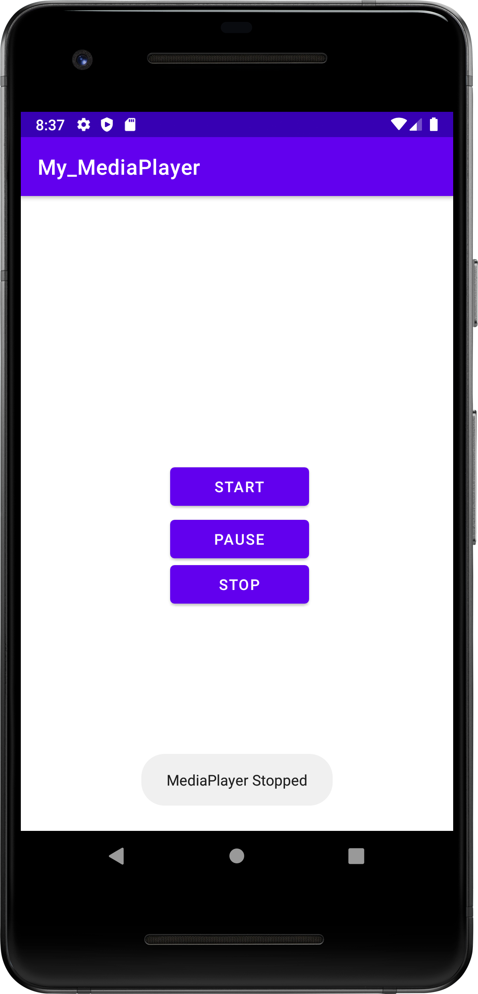

**Problem Statement 22-** Develop an android application to create an video media player

**Objective-** To create media player

**Activity_main.xml file**

<?xml version="1.0" encoding="utf-8"?>  
<androidx.constraintlayout.widget.ConstraintLayout xmlns:android="http://schemas.android.com/apk/res/android"  
 xmlns:app="http://schemas.android.com/apk/res-auto"  
 xmlns:tools="http://schemas.android.com/tools"  
 android:layout_width="match_parent"  
 android:layout_height="match_parent"  
 tools:context=".MainActivity">  
  
 <VideoView  
 android:id="@+id/v1"  
 android:layout_width="wrap_content"  
 android:layout_height="wrap_content"  
 app:layout_constraintBottom_toBottomOf="parent"  
 app:layout_constraintEnd_toEndOf="parent"  
 app:layout_constraintStart_toStartOf="parent"  
 app:layout_constraintTop_toTopOf="parent" />  
  
</androidx.constraintlayout.widget.ConstraintLayout>

# MainActivity.java

package com.example.my_videoplayer;  
  
import androidx.appcompat.app.AppCompatActivity;  
  
import android.net.Uri;  
import android.os.Bundle;  
import android.widget.MediaController;  
import android.widget.VideoView;  
  
public class MainActivity extends AppCompatActivity {  
  
 @Override  
 protected void onCreate(Bundle savedInstanceState) {  
 super.onCreate(savedInstanceState);  
 setContentView(R.layout.*activity_main*);  
 VideoView v2=findViewById(R.id.*v1*);  
 String VideoPath="android.resource://"+getPackageName()+"/"+R.raw.*banana*;  
 Uri uri= Uri.*parse*(VideoPath);  
 v2.setVideoURI(uri);  
  
 MediaController mc=new MediaController(this);  
 v2.setMediaController(mc);  
 mc.setAnchorView(v2);  
 }  
}

# AndroidManifest.xml file

<?xml version="1.0" encoding="utf-8"?>  
<manifest xmlns:android="http://schemas.android.com/apk/res/android"  
 xmlns:tools="http://schemas.android.com/tools">  
  
 <application  
 android:allowBackup="true"  
 android:dataExtractionRules="@xml/data_extraction_rules"  
 android:fullBackupContent="@xml/backup_rules"  
 android:icon="@mipmap/ic_launcher"  
 android:label="@string/app_name"  
 android:roundIcon="@mipmap/ic_launcher_round"  
 android:supportsRtl="true"  
 android:theme="@style/Theme.My_VideoPlayer"  
 tools:targetApi="31">  
 <activity  
 android:name=".MainActivity"  
 android:exported="true">  
 <intent-filter>  
 <action android:name="android.intent.action.MAIN" />  
  
 <category android:name="android.intent.category.LAUNCHER" />  
 </intent-filter>  
  
 <meta-data  
 android:name="android.app.lib_name"  
 android:value="" />  
 </activity>  
 </application>  
  
</manifest>

**OUTPUT**

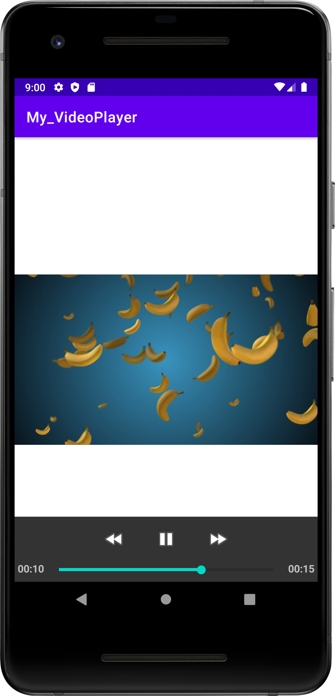

**Problem Statement 23-** Develop an android application to enlist all the inbuild sensors in a particular device

**Objective-** Enlisting all the inbuild sensors of a device

**Activity_main.xml file**

<?xml version="1.0" encoding="utf-8"?>  
<androidx.constraintlayout.widget.ConstraintLayout xmlns:android="http://schemas.android.com/apk/res/android"  
 xmlns:app="http://schemas.android.com/apk/res-auto"  
 xmlns:tools="http://schemas.android.com/tools"  
 android:layout_width="match_parent"  
 android:layout_height="match_parent"  
 tools:context=".MainActivity">  
  
 <ListView  
 android:id="@+id/l1"  
 android:layout_width="wrap_content"  
 android:layout_height="wrap_content"  
 app:layout_constraintBottom_toBottomOf="parent"  
 app:layout_constraintEnd_toEndOf="parent"  
 app:layout_constraintStart_toStartOf="parent"  
 app:layout_constraintTop_toTopOf="parent" />  
  
</androidx.constraintlayout.widget.ConstraintLayout>

# MainActivity.java

package com.example.my_sensordevice;  
  
import androidx.appcompat.app.AppCompatActivity;  
  
import android.content.Context;  
import android.hardware.Sensor;  
import android.hardware.SensorManager;  
import android.os.Bundle;  
import android.widget.ArrayAdapter;  
import android.widget.ListAdapter;  
import android.widget.ListView;  
  
import java.util.ArrayList;  
import java.util.List;  
  
public class MainActivity extends AppCompatActivity {  
 ListView lv;  
SensorManager sm;  
 @Override  
 protected void onCreate(Bundle savedInstanceState) {  
 super.onCreate(savedInstanceState);  
 setContentView(R.layout.*activity_main*);  
 lv=findViewById(R.id.*l1*);  
 List sensorList=new ArrayList<String>();  
  
 sm=((SensorManager) getSystemService(Context.*SENSOR_SERVICE*));  
 List<Sensor> sensors=sm.getSensorList(Sensor.*TYPE_ALL*);  
  
 for(Sensor i:sensors)  
 {  
 sensorList.add(i.getName());  
 }  
 ListAdapter sensorAdapter = new ArrayAdapter<String>(this,  
 android.R.layout.*simple_list_item_1*, sensorList);  
 lv.setAdapter(sensorAdapter);  
  
 SensorManager sensorManager = ((SensorManager) getSystemService(Context.*SENSOR_SERVICE*));  
 if (sensorManager.getDefaultSensor(Sensor.*TYPE_ACCELEROMETER*) != null) {  
 //Sensor is available - do something here  
 }  
 }  
}

# AndroidManifest.xml file

<?xml version="1.0" encoding="utf-8"?>  
<manifest xmlns:android="http://schemas.android.com/apk/res/android"  
 xmlns:tools="http://schemas.android.com/tools">  
  
 <application  
 android:allowBackup="true"  
 android:dataExtractionRules="@xml/data_extraction_rules"  
 android:fullBackupContent="@xml/backup_rules"  
 android:icon="@mipmap/ic_launcher"  
 android:label="@string/app_name"  
 android:roundIcon="@mipmap/ic_launcher_round"  
 android:supportsRtl="true"  
 android:theme="@style/Theme.My_SensorDevice"  
 tools:targetApi="31">  
 <activity  
 android:name=".MainActivity"  
 android:exported="true">  
 <intent-filter>  
 <action android:name="android.intent.action.MAIN" />  
  
 <category android:name="android.intent.category.LAUNCHER" />  
 </intent-filter>  
  
 <meta-data  
 android:name="android.app.lib_name"  
 android:value="" />  
 </activity>  
 </application>  
  
</manifest>

**OUTPUT**

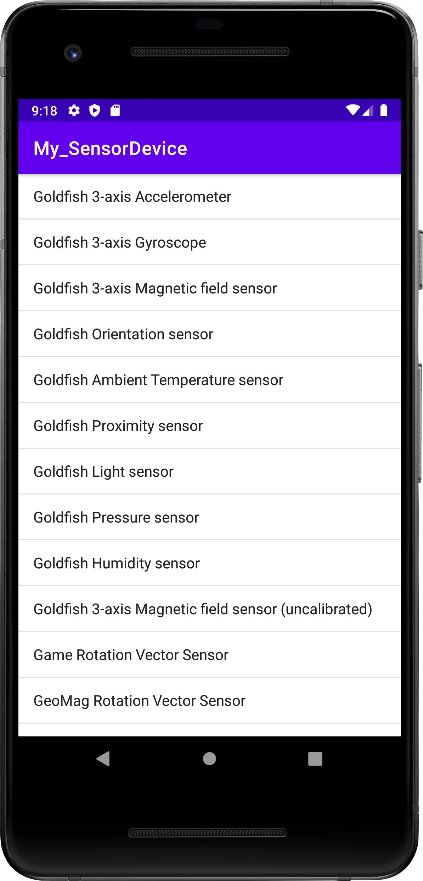 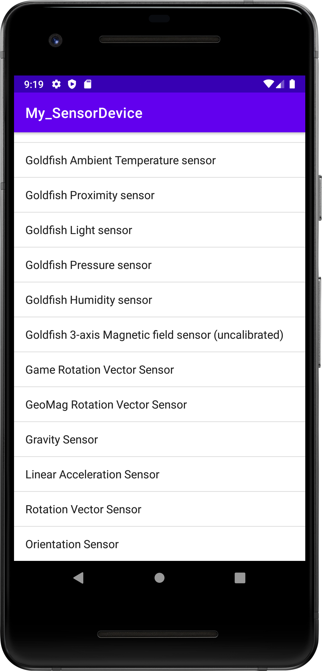

**Problem Statement 24-** Develop an android application to fetch contacts data and display it on your application

**Objective-** to fetch data from contacts application

**Activity_main.xml file**

<?xml version="1.0" encoding="utf-8"?>  
<ScrollView xmlns:android="http://schemas.android.com/apk/res/android"  
 xmlns:app="http://schemas.android.com/apk/res-auto"  
 xmlns:tools="http://schemas.android.com/tools"  
 android:layout_width="match_parent"  
 android:layout_height="match_parent"  
 android:padding="16sp"  
 android:scrollbarSize="25sp"  
 tools:context=".MainActivity">  
 <RelativeLayout  
 android:layout_width="match_parent"  
 android:layout_height="wrap_content"  
 android:orientation="vertical"  
 android:padding="8dp"  
 android:gravity="center_horizontal">  
  
 <Button  
 android:layout_width="100dp"  
 android:layout_height="40dp"  
 android:text="Press"  
 android:id="@+id/b"  
 android:onClick="Contacts"/>  
  
 <TextView  
 android:id="@+id/textview"  
 android:layout_width="wrap_content"  
 android:layout_height="wrap_content"  
 app:layout_constraintBottom_toBottomOf="parent"  
 app:layout_constraintEnd_toEndOf="parent"  
 app:layout_constraintStart_toStartOf="parent"  
 app:layout_constraintTop_toTopOf="parent"  
 android:layout_marginTop="50dp"  
 />  
 </RelativeLayout>  
</ScrollView>

# MainActivity.java

package com.example.my_contacts;  
  
import androidx.appcompat.app.AppCompatActivity;  
import androidx.core.app.ActivityCompat;  
import androidx.core.content.ContextCompat;  
  
import android.Manifest;  
import android.annotation.SuppressLint;  
import android.content.ContentResolver;  
import android.content.pm.PackageManager;  
import android.database.Cursor;  
import android.net.Uri;  
import android.os.Bundle;  
import android.provider.ContactsContract;  
import android.util.Log;  
import android.view.View;  
import android.widget.TextView;  
  
public class MainActivity extends AppCompatActivity {  
  
 TextView t;  
 @Override  
 protected void onCreate(Bundle savedInstanceState) {  
 super.onCreate(savedInstanceState);  
 setContentView(R.layout.activity_main);  
 t=findViewById(R.id.textview);  
  
 }  
 public void Contacts(View v)  
 {  
 getContacts();  
 }  
 private void getContacts(){  
 StringBuffer sb=new StringBuffer();  
 sb.append("......Contact Details......\n");  
 if(ContextCompat.checkSelfPermission(this, Manifest.permission.READ_CONTACTS)!= PackageManager.PERMISSION_GRANTED)  
 ActivityCompat.requestPermissions(this, new String[]{Manifest.permission.READ_CONTACTS},0);  
 ContentResolver cr=getContentResolver();  
 Uri uri= ContactsContract.CommonDataKinds.Phone.CONTENT_URI;  
 Cursor c=cr.query(uri,null,null,null,null);  
 Log.i("msg", Integer.toString(c.getCount()));  
 if(c.getCount()>0)  
 {  
 while(c.moveToNext())  
 {  
 @SuppressLint("Range") String contactName=c.getString(c.getColumnIndex(ContactsContract.CommonDataKinds.Phone.DISPLAY_NAME));  
 @SuppressLint("Range") String contactNumber=c.getString(c.getColumnIndex(ContactsContract.CommonDataKinds.Phone.NUMBER));  
 sb.append(contactName+" : ");  
 sb.append(contactNumber+"\n");  
 }  
 }  
 t.setText(sb);  
 }  
}

# AndroidManifest.xml file

<?xml version="1.0" encoding="utf-8"?>  
<manifest xmlns:android="http://schemas.android.com/apk/res/android"  
 xmlns:tools="http://schemas.android.com/tools">  
<uses-permission android:name="android.permission.READ_CONTACTS"></uses-permission>  
 <uses-permission android:name="android.permission.WRITE_CONTACTS"></uses-permission>  
 <application  
 android:allowBackup="true"  
 android:dataExtractionRules="@xml/data_extraction_rules"  
 android:fullBackupContent="@xml/backup_rules"  
 android:icon="@mipmap/ic_launcher"  
 android:label="@string/app_name"  
 android:roundIcon="@mipmap/ic_launcher_round"  
 android:supportsRtl="true"  
 android:theme="@style/Theme.My_contacts"  
 tools:targetApi="31">  
 <activity  
 android:name=".MainActivity"  
 android:exported="true">  
 <intent-filter>  
 <action android:name="android.intent.action.MAIN" />  
  
 <category android:name="android.intent.category.LAUNCHER" />  
 </intent-filter>  
  
 <meta-data  
 android:name="android.app.lib_name"  
 android:value="" />  
 </activity>  
 </application>  
  
</manifest>

**OUTPUT**

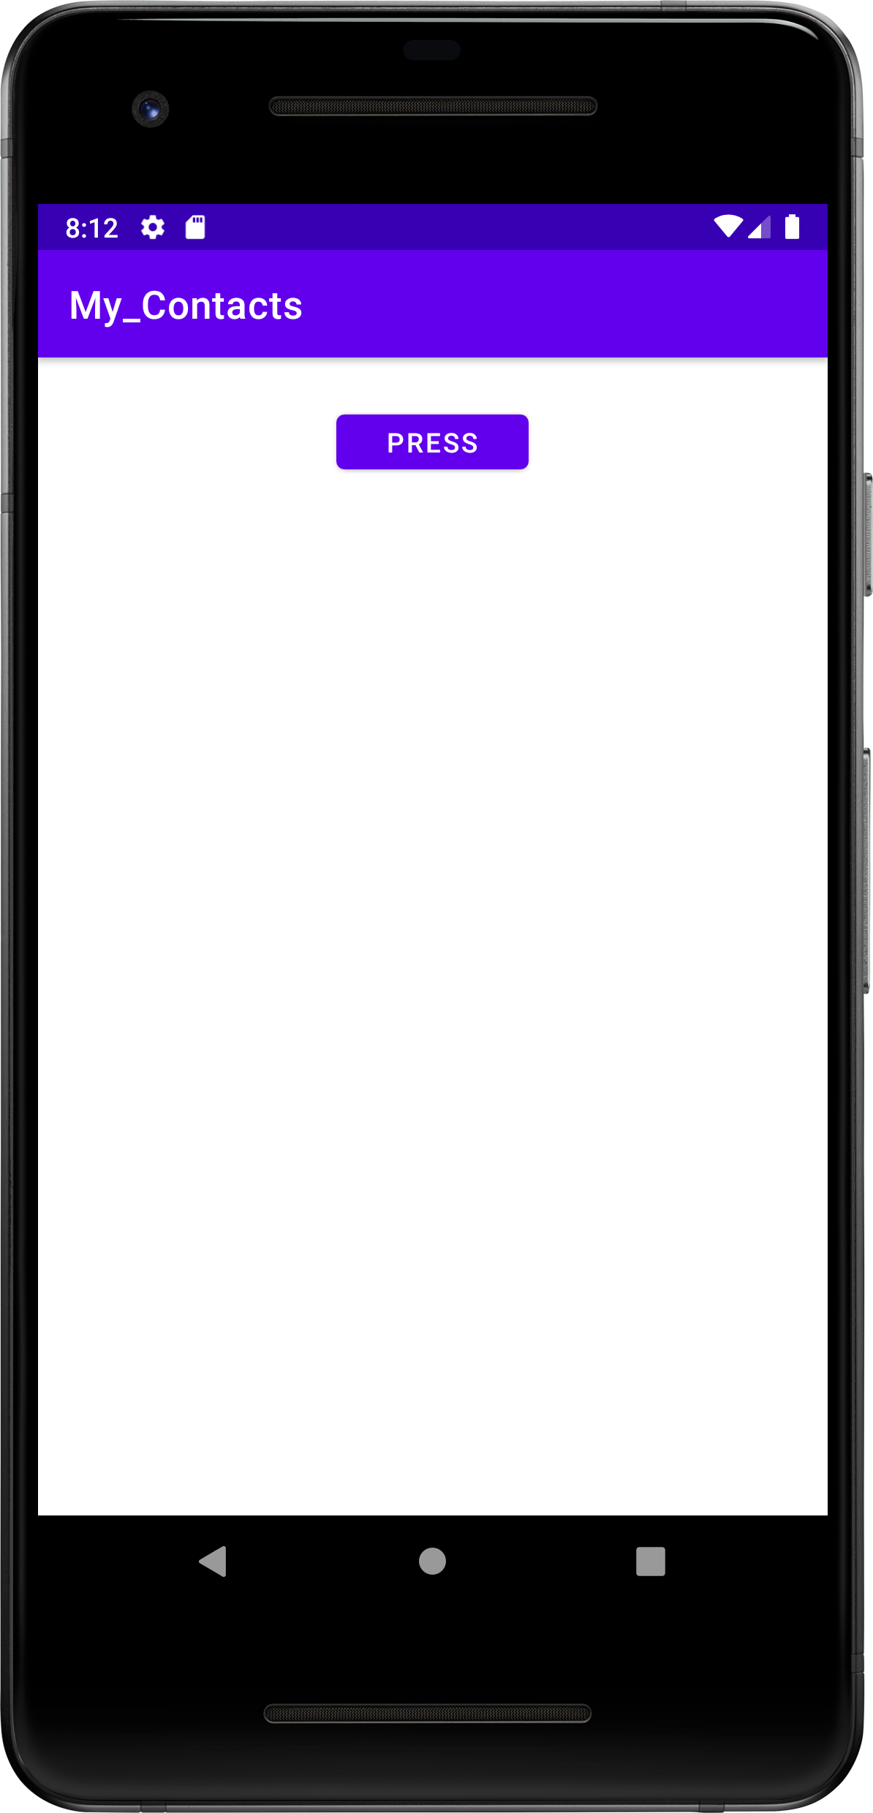 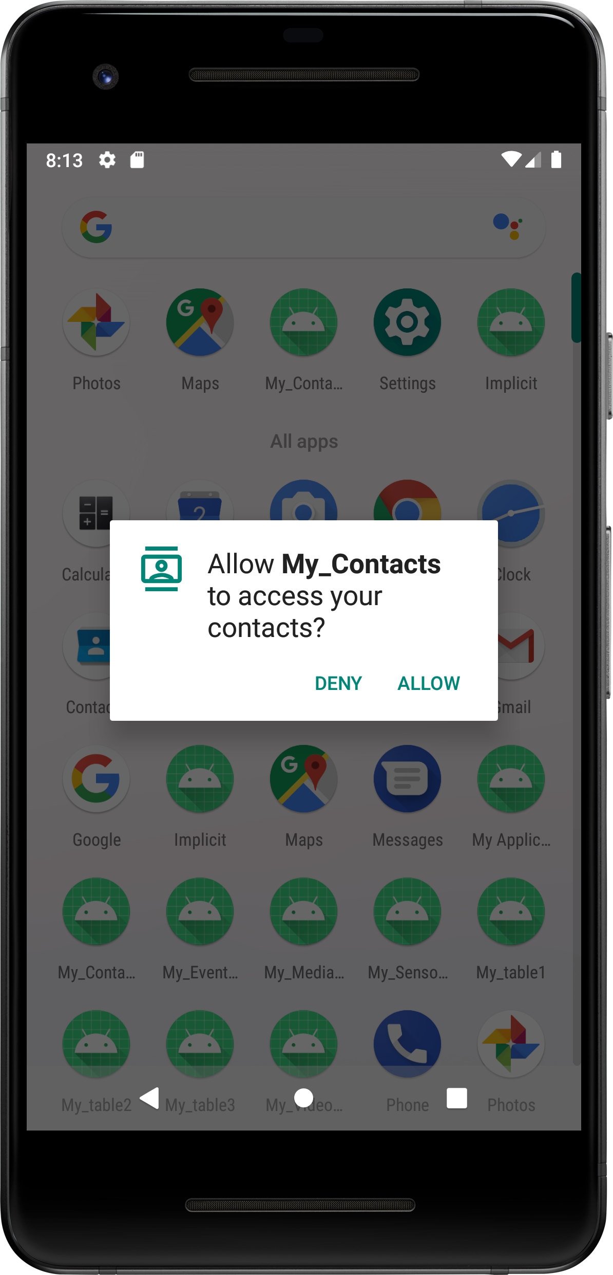 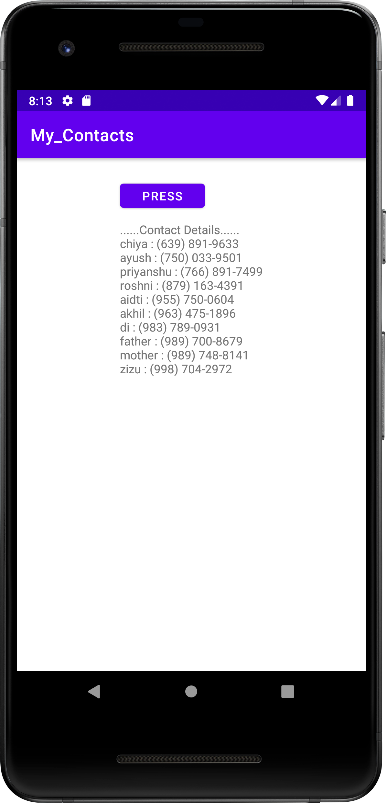

**Problem Statement 25-** Develop an android application to insert, fetch and delete data from the database

**Objective-** to insert, fetch and delete data from the database

**Activity_main.xml file**

<?xml version="1.0" encoding="utf-8"?>  
<RelativeLayout xmlns:android="http://schemas.android.com/apk/res/android"  
 xmlns:app="http://schemas.android.com/apk/res-auto"  
 xmlns:tools="http://schemas.android.com/tools"  
 android:layout_width="match_parent"  
 android:layout_height="match_parent"  
 tools:context=".MainActivity">  
  
 <TextView  
 android:layout_width="wrap_content"  
 android:layout_height="wrap_content"  
 app:layout_constraintBottom_toBottomOf="parent"  
 app:layout_constraintEnd_toEndOf="parent"  
 app:layout_constraintStart_toStartOf="parent"  
 app:layout_constraintTop_toTopOf="parent"  
 android:id="@+id/tv1"/>  
 <EditText  
 android:layout_width="100dp"  
 android:layout_height="50dp"  
 android:layout_marginTop="50dp"  
 android:layout_marginLeft="150dp"  
 android:id="@+id/et1"  
 android:hint="Name"  
 android:inputType="text"  
 android:layout_below="@+id/tv1"  
 />  
  
 <Button  
 android:layout_width="150dp"  
 android:layout_height="50dp"  
 android:id="@+id/btn1"  
 android:layout_marginLeft="120dp"  
 android:layout_below="@+id/et1"  
 android:text="Insert Data"/>  
  
 <Button  
 android:layout_width="150dp"  
 android:layout_height="50dp"  
 android:id="@+id/btn2"  
 android:layout_marginLeft="120dp"  
 android:layout_below="@+id/btn1"  
 android:text="Fetch Data"/>  
  
 <Button   
 android:layout_width="150dp"  
 android:layout_height="50dp"  
 android:id="@+id/btn3"  
 android:layout_marginLeft="120dp"  
 android:layout_below="@+id/btn2"  
 android:text="Delete Data"/>  
  
</RelativeLayout>

# MainActivity.java

package com.example.my_data;  
  
import androidx.appcompat.app.AppCompatActivity;  
  
import android.database.Cursor;  
import android.database.sqlite.SQLiteDatabase;  
import android.os.Bundle;  
import android.view.View;  
import android.widget.Button;  
import android.widget.EditText;  
import android.widget.TextView;  
import android.widget.Toast;  
  
public class MainActivity extends AppCompatActivity {  
 Button b1, b2, b3;  
 EditText e1;  
 TextView t1;  
 SQLiteDatabase db;  
 String qry = "";  
 Cursor c;  
 String name = " ";  
  
 @Override  
 protected void onCreate(Bundle savedInstanceState) {  
 super.onCreate(savedInstanceState);  
 setContentView(R.layout.activity_main);  
 b1 = findViewById(R.id.btn1);  
 b2 = findViewById(R.id.btn2);  
 b3 = findViewById(R.id.btn3);  
 e1 = findViewById(R.id.et1);  
 t1 = findViewById(R.id.tv1);  
  
 db = openOrCreateDatabase("database", MODE_PRIVATE, null);  
 db.execSQL(“create table if not exists stud1(Name varchar(200) not null)”);  
 b1.setOnClickListener(new View.OnClickListener() {  
 @Override  
 public void onClick(View view) {  
 String qry=”insert into stud1 values(‘”+e1.getText().toString()+”’)”;  
 db.execSQL(qry);  
 Toast.makeText(MainActivity.this, "Data inserted successfully", Toast.LENGTH_LONG).show();  
 }  
 });  
  
 b2.setOnClickListener(new View.OnClickListener() {  
 @Override  
 public void onClick(View view) {  
 String qry = “select * from stud1”;  
 try {  
 c = db.rawQuery(qry, null);  
 int row = c.getCount();  
 if (row == 0) {  
 Toast.makeText(MainActivity.this, "No data found", Toast.LENGTH_SHORT).show();  
 } else {  
 Toast.makeText(MainActivity.this, "Data found", Toast.LENGTH_SHORT).show();  
 c.moveToNext();  
 name = c.getString(0);  
 t1.setText("Name=" + name);  
 }  
 } catch (Exception e) {  
 Toast.makeText(MainActivity.this, "Error Occurred", Toast.LENGTH_LONG).show();  
 }  
 }  
 });  
  
 b3.setOnClickListener(new View.OnClickListener() {  
 @Override  
 public void onClick(View view) {  
 try {  
 qry = “delete from stud1 where name=’ ” + e1.getText() + “ ’ ”;  
 db.execSQL(qry);  
 Toast.makeText(MainActivity.this, "deleted", Toast.LENGTH_LONG).show();  
 } catch (Exception e) {  
 Toast.makeText(MainActivity.this, "not deleted", Toast.LENGTH_LONG).show();  
 }  
 }  
 });  
 }  
}

# AndroidManifest.xml file

<?xml version="1.0" encoding="utf-8"?>  
<manifest xmlns:android="http://schemas.android.com/apk/res/android"  
 xmlns:tools="http://schemas.android.com/tools">  
<uses-permission android:name="android.permission.READ_CONTACTS"></uses-permission>  
 <uses-permission android:name="android.permission.WRITE_CONTACTS"></uses-permission>  
 <application  
 android:allowBackup="true"  
 android:dataExtractionRules="@xml/data_extraction_rules"  
 android:fullBackupContent="@xml/backup_rules"  
 android:icon="@mipmap/ic_launcher"  
 android:label="@string/app_name"  
 android:roundIcon="@mipmap/ic_launcher_round"  
 android:supportsRtl="true"  
 android:theme="@style/Theme.My_contacts"  
 tools:targetApi="31">  
 <activity  
 android:name=".MainActivity"  
 android:exported="true">  
 <intent-filter>  
 <action android:name="android.intent.action.MAIN" />  
  
 <category android:name="android.intent.category.LAUNCHER" />  
 </intent-filter>  
  
 <meta-data  
 android:name="android.app.lib_name"  
 android:value="" />  
 </activity>  
 </application>  
  
</manifest>

**OUTPUT**

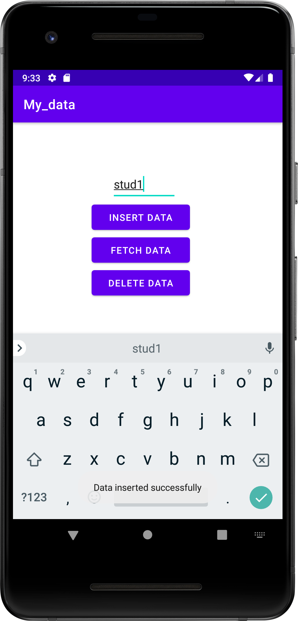 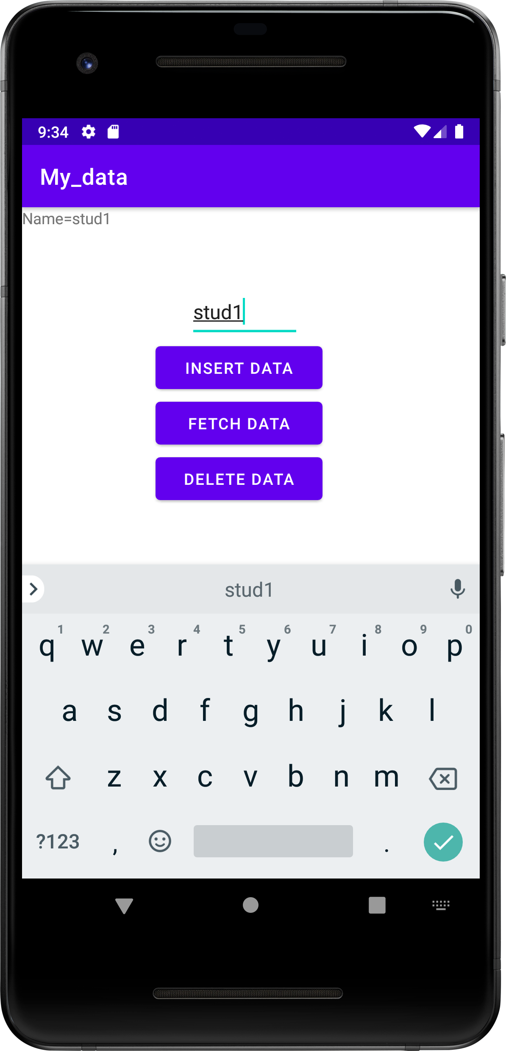 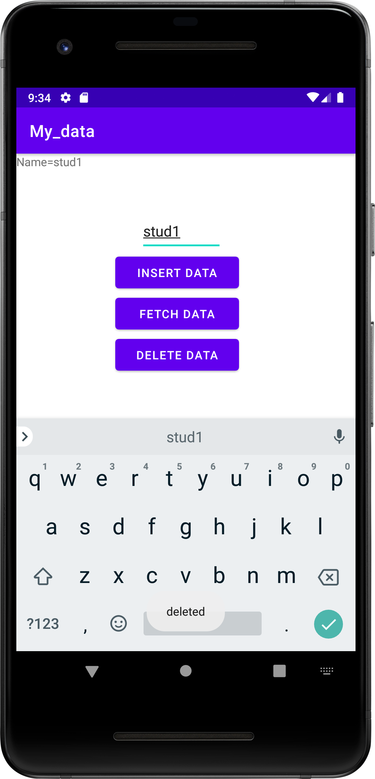

**Problem Statement 26-** Develop an android application to implement Bluetooth Adapter class. Create three buttons and provide functionality as follows

1. On and Off the Bluetooth Adapter
2. Scanning for near by available devices
3. List out all the paired devices

**Activity_main.xml file**

<?xml version="1.0" encoding="utf-8"?>  
<RelativeLayout xmlns:android="http://schemas.android.com/apk/res/android"  
 xmlns:app="http://schemas.android.com/apk/res-auto"  
 xmlns:tools="http://schemas.android.com/tools"  
 android:layout_width="match_parent"  
 android:layout_height="match_parent"  
 tools:context=".MainActivity">  
  
 <Button  
 android:id="@+id/ONN"  
 android:layout_width="100dp"  
 android:layout_height="70dp"  
 android:layout_marginTop="100dp"  
 android:text="ON"  
 android:layout_marginLeft="30dp"/>  
  
 <Button  
 android:id="@+id/OFFF"  
 android:layout_width="100dp"  
 android:layout_height="70dp"  
 android:layout_centerHorizontal="true"  
 android:layout_marginTop="100dp"  
 android:text="OFF"  
 android:layout_toRightOf="@+id/ONN"  
 android:layout_marginLeft="30dp"/>  
  
 <Button  
 android:id="@+id/PD"  
 android:layout_width="100dp"  
 android:layout_height="70dp"  
 android:layout_centerHorizontal="true"  
 android:layout_marginTop="100dp"  
 android:text="Paired Devices"  
 android:layout_toRightOf="@+id/OFFF"  
 android:layout_marginLeft="30dp"/>  
  
 <TextView  
 android:id="@+id/tv"  
 android:layout_width="wrap_content"  
 android:layout_height="wrap_content"  
 android:layout_centerHorizontal="true"  
 android:layout_marginTop="300dp"  
 android:textSize="20dp"/>   
</RelativeLayout>

# MainActivity.java

package com.example.mybluetoothadapter;  
  
import androidx.appcompat.app.AppCompatActivity;  
import androidx.core.app.ActivityCompat;  
import android.Manifest;  
import android.bluetooth.BluetoothAdapter;  
import android.bluetooth.BluetoothDevice;  
import android.content.Intent;  
import android.content.pm.PackageManager;  
import android.os.Bundle;  
import android.view.View;  
import android.widget.Button;  
import android.widget.TextView;  
import java.util.Set;  
  
public class MainActivity extends AppCompatActivity {  
  
 @Override  
 protected void onCreate(Bundle savedInstanceState) {  
 super.onCreate(savedInstanceState);  
 setContentView(R.layout.*activity_main*);  
 Button btOn, btOff, btPd;  
 TextView tv;  
  
 btOn = findViewById(R.id.*ONN*);  
 btOff = findViewById(R.id.*OFFF*);  
 btPd = findViewById(R.id.*PD*);  
 tv = findViewById(R.id.*tv*);  
 BluetoothAdapter ba = BluetoothAdapter.*getDefaultAdapter*();  
  
 btOn.setOnClickListener(new View.OnClickListener() {  
 @Override  
 public void onClick(View view) {  
 if (!ba.isEnabled()) {  
 Intent i = new Intent(ba.*ACTION_REQUEST_ENABLE*);  
 if (ActivityCompat.*checkSelfPermission*(MainActivity.this, Manifest.permission.*BLUETOOTH_CONNECT*) != PackageManager.*PERMISSION_GRANTED*) {  
 }  
  
 startActivity(i);  
 tv.setText("Active");  
 } else {  
 tv.setText("Active");  
 }  
 }  
 });  
  
 btOff.setOnClickListener(new View.OnClickListener() {  
 @Override  
 public void onClick(View view) {  
 if (ActivityCompat.*checkSelfPermission*(MainActivity.this, Manifest.permission.*BLUETOOTH_CONNECT*) != PackageManager.*PERMISSION_GRANTED*) {  
 }  
 ba.disable();  
 tv.setText("Disabled");  
 }  
 });

btPd.setOnClickListener(new View.OnClickListener() {  
 @Override  
 public void onClick(View view) {  
 if (ActivityCompat.*checkSelfPermission*(MainActivity.this, Manifest.permission.*BLUETOOTH_CONNECT*) != PackageManager.*PERMISSION_GRANTED*) {  
 }  
 Set<BluetoothDevice> pairedDevices = ba.getBondedDevices();  
 if (pairedDevices.size() > 0) {  
 for (BluetoothDevice device : pairedDevices) {  
 String deviceName = device.getName();  
 tv.append(deviceName + "\n");  
 }  
 }  
 }  
 });  
 }  
}

# AndroidManifest.xml file

<?xml version="1.0" encoding="utf-8"?>  
<manifest xmlns:android="http://schemas.android.com/apk/res/android"  
 xmlns:tools="http://schemas.android.com/tools">  
 <uses-permission android:name="android.permission.BLUETOOTH"></uses-permission>  
 <uses-permission android:name="android.permission.BLUETOOTH_CONNECT"></uses-permission>  
 <uses-permission android:name="android.permission.BLUETOOTH_ADMIN"></uses-permission>  
 <uses-permission android:name="android.permission.BLUETOOTH_SCAN"></uses-permission>  
  
 <application  
 android:allowBackup="true"  
 android:dataExtractionRules="@xml/data_extraction_rules"  
 android:fullBackupContent="@xml/backup_rules"  
 android:icon="@mipmap/ic_launcher"  
 android:label="@string/app_name"  
 android:roundIcon="@mipmap/ic_launcher_round"  
 android:supportsRtl="true"  
 android:theme="@style/Theme.MyBluetoothAdapter"  
 tools:targetApi="31">  
 <activity  
 android:name=".MainActivity"  
 android:exported="true">  
 <intent-filter>  
 <action android:name="android.intent.action.MAIN" />  
  
 <category android:name="android.intent.category.LAUNCHER" />  
 </intent-filter>  
  
 <meta-data  
 android:name="android.app.lib_name"  
 android:value="" />  
 </activity>  
 </application>  
  
</manifest>

**OUTPUT**

